

LAB MANUAL

**ECSB5103-FAB LAB**

**ACADEMIC YEAR :** 2022-2023

**PROGRAMME :** B.TECH

**COURSE CATEGORY :** PRACTICAL

**INCHARGE :** Ms.S.GOWSALYA

**DEPARTMENT :** COMPUTER SCIENCE AND ENGINEERING

**SEMESTER :** 1

**EX: NO:1 To study the construction and working of CRT, LCD, LED and it’s troubleshooting.**

**Aim**

**To study the construction and working of CRT, LCD, LED and it’s troubleshooting.**

**principles**

A monitor is used to display the output of any computer system. A good display makes all the difference and no doubt enhances the user experience. The innovation in the display technologies has improved the quality of the display devices including monitors. Now the desktop computers are available with a variety of displays ranging from technologically obsolete **CRT monitors** to latest slim **LCD, LED or OLED monitors**.

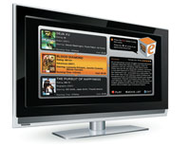

*Fig. 1: A Representational Image of Latest Slim LCD Monitor*

A computer monitor, technically termed as visual display unit is an output device that presents the information from the CPU on the screen working as an interface between CPU and the user. A cable connects the monitor to a video adaptor or video card which is set up on the motherboard of the computer. The CPU (Central Processing Unit) sends instruction to the video adaptor telling what needs to be displayed on the screen. The video adaptor converts the instructions into a set of corresponding signals and sends to the monitor. Monitor contains a circuitry that generates the picture on the screen from the set of signals.

The major parameters that measure the performance of a monitor are luminance, contrast ratio, resolution, dot pitch, response time, refresh rate and power consumption. The common problem that arises in monitors is dead pixels, blurred screen, phosphor-burn, etc.

**Display Technologies**

Since the beginning of computer era, there have been a number of technologies used for the display of output. The major technologies are CRT, LCD, Plasma, LED and OLED displays.

**working**

**1.      Cathode Ray Tube (CRT) Monitors**

These monitors employ the CRT technology to create a display. The CRT (also known as picture tube) receives the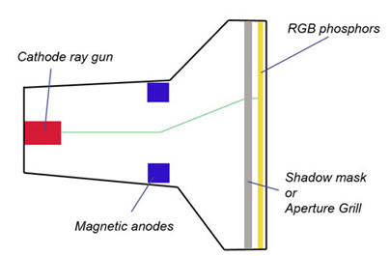

*Fig. 3: A Diagram Illustrating CRT Technology Used in Monitors to Create Display*

signals through a cable and the signal is decoded by the display controller which finally appears on a phosphor screen. The detailed working is as following:

As shown in the image CRTs have a conical shape and there is an electron gun or cathode ray gun at the back end of the monitor and a phosphor screen in the front. The electron gun fires a stream of electrons towards the display screen through a vacuum tube. This stream of electrons is also known as cathode rays. At the middle of the monitor, there are magnetic anodes which are magnetized in accordance with the instruction from the display controller. When electrons (cathode rays) pass through the magnetic anodes, they are pushed or pulled in one direction or other depending on the magnetic field on the anodes. This directs the electrons towards the correct part of phosphor coating inside the display glass. When electrons strikes the phosphor coated screen passing through a mesh (shadow mask or aperture grill), the phosphor lights up making a displayable dot on the computer screen. There are three different colored phosphors (Red, Green and Blue) for each pixel and the color of the pixel depends on the phosphor on which the electrons strike.

This image shows the color combination schematic for phosphor particles. The monitor that has a single electron gun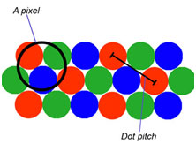

*Fig. 4: An Image Showing Color Combination Schematic For Phosphor Particles*

has three different phosphors for each pixel. A cathode ray strikes to one or more of these phosphors and the corresponding colored pixel appear on the screen. However high quality monitors use individual electron gun for each color which improves the image quality. Distance for two same colored phosphors (for single electron gun monitors) is known as dot pitch. Lesser the dot pitch higher is the quality of monitors.

**LCD Monitor**

**LCD Monitors**

LCD, Liquid Crystal Display or also known as Liquid Crystal Diode is one of the most popular display technologies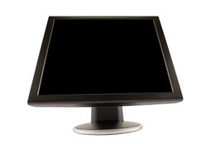

*Fig. 6: A Representational Image of LCD or Liquid Crystal Diode Monitor*

currently. LCD monitors are lightweight, compact, occupy less space, consume low power and are available in a reasonable price. Currently there are two types of LCD technology in use – Active matrix LCD technology or TFT and Passive matrix technology. The TFT technology is more reliable with better image quality while the passive matrix technology has a slower response and gradually becoming outdated.

As the name indicates, liquid crystals are the key elements of the display screen. By manipulating the crystal we can change the way they interacts with the light. There is a display controller in the monitor which receives the display signals from the video adaptor in the motherboard. The display controller controls two things – the electric signals to the liquid crystals and the back light. Structure of an LCD is shown in the below images (Also see how LCD works).

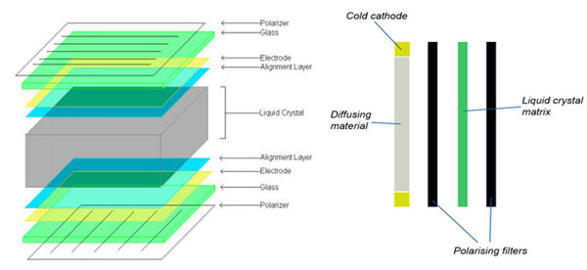

*Fig. 7: A Diagram Showing Structure and Working of a LCD*

The liquid crystals used in the LCD are Twisted Nemantic (TN), a type of liquid crystals that are twisted at 90owith the surface. In this state, crystals allow the light to pass through the polarizer but on applying a voltage, they get untwisted and block the light to passing through the polarizer. The display controller starts the backlight that passes through the first piece of the glass. At the same time the display controller also send the electrical currents to the liquid crystal molecules to align and allowing the varying level of light to pass through the second piece of glass, forming the desired picture on the screen. In color monitors, each pixel is made of three liquid crystal cells fronted with red, green and blue filters. The light passing through the filtered screen forms the color what you see on the monitor. A wide range of colors are formed by varying the intensity of colored pixels.

**LED Monitors**

**LED Monitors**

In the previous decade, the display technology has changed significantly. LED displays are one of the latest developments.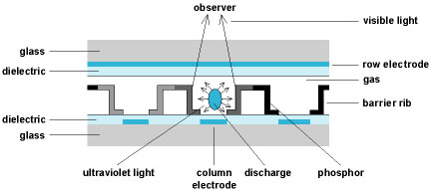

*Fig. 8 : A Representational Image of a LED Monitor*

In this field. LED monitors use light emitting diodes that acts as a performance booster in the monitors. Basically LED monitors are the LCD monitors with a LED backlight to power up the LCD panel. It means that LEDs are placed behind or around the LCD panel to enhance the luminosity and video definition of the monitor screen.

As we have seen in the above section of LCD monitors, they use a cold cathode light as backlight. In the LED monitors all the concepts are same except this backlight, which is replaced by LEDs.

**Result**

The construction and working of CRT, LCD, LED and it’s troubleshooting is executed successfully.

**EX:NO :2 Determine the video memory size on your PC/Laptop**

AIM

To Determine the video memory size on your PC/Laptop.

Principle :

## Windows 10

Press the [Windows key](https://www.computerhope.com/jargon/w/winkey.htm), type **Display settings**, and press Enter.

On the left side of the screen, under *System*, click the **Display** option.

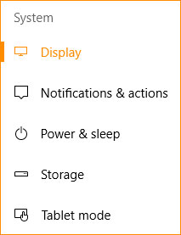

At the bottom of the page, under the *Multiple Displays* section, click **Advanced display settings**.

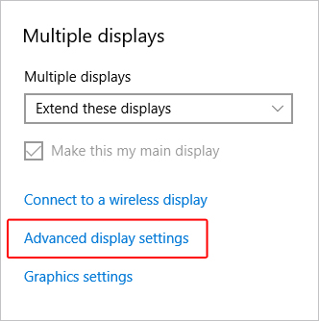

On the next screen, click **Display adapter properties for Display 1** or the adapter you want to view.

In the window that appears, on the *Adapter* tab, your video card's [VRAM](https://www.computerhope.com/jargon/v/vram.htm) and its specifications are displayed next to **Dedicated Video Memory**.

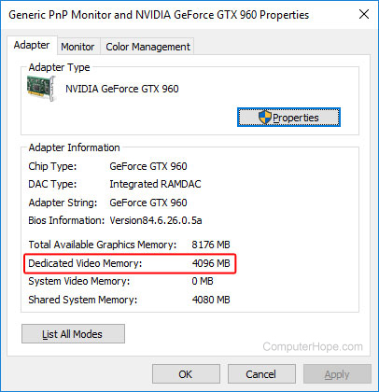

1. [Open the Control Panel](https://www.computerhope.com/issues/control-panel.htm).
2. Select **Display**.
3. Select **Screen Resolution**.
4. Select **Advanced Settings**.
5. Click the **Adapter** tab if not already selected. The amount of **Total Available Graphics Memory** and **Dedicated Video Memory** available on your system is displayed.

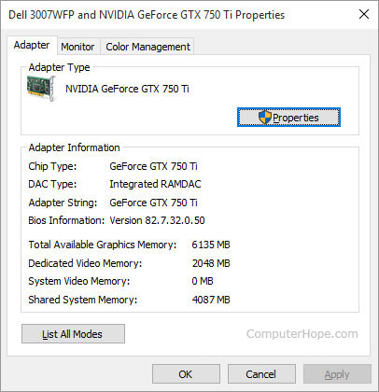

## Windows Vista and Windows 7

1. Press the [Windows key](https://www.computerhope.com/jargon/w/winkey.htm), type **Control Panel**, and then press Enter.
2. Under the **Appearance and Personalization**, click **Adjust screen resolution**.
3. On the middle of the right side of the screen, click the **Advanced settings**.
4. A new window should appear with your video adapter's properties, similar to the image shown below.
5. Your video card's memory is displayed on the *Adapter* [tab](https://www.computerhope.com/jargon/t/tab.htm), next to the **Dedicated Video Memory** entry (shown below).

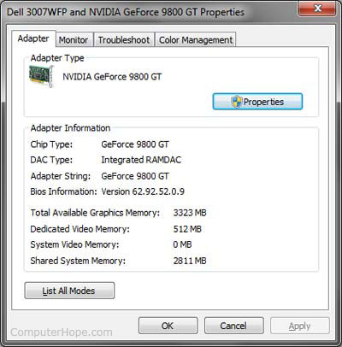

## Windows XP

1. Right-click the [desktop](https://www.computerhope.com/jargon/d/desktop.htm) and select **Properties**.
2. Click the **Settings** tab.
3. Click the **Advanced** button.
4. Click the **Adapter** tab.
5. Your GPU's memory is shown next to the **Memory Size** entry, under **Adapter Information**.

## macOS X

1. From the [Apple Menu](https://www.computerhope.com/jargon/a/applmenu.htm) in the upper-left corner of your screen, select **About This Mac**.
2. In the **Graphics** information line, you see details about your graphics hardware, including the amount of video memory.  
     
   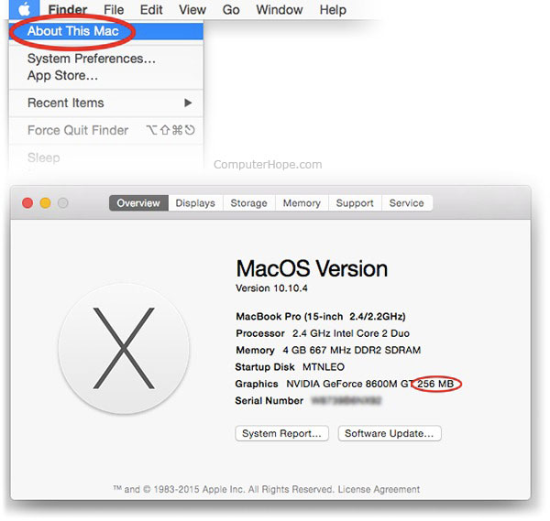

## Linux

On a [Linux](https://www.computerhope.com/jargon/l/linux.htm) system, you can see the specifics of your graphics hardware using the [command line](https://www.computerhope.com/jargon/c/commandi.htm) utility **lspci**. Follow these steps to find out how much video memory you have.

1. First, run **lspci** with no options to list information about all your [PCI](https://www.computerhope.com/jargon/p/pci.htm) devices. The line you are looking for is labeled **VGA compatible controller**.  
     
   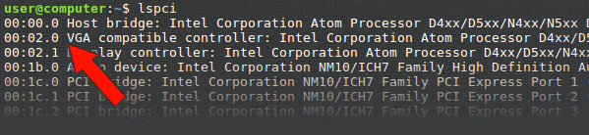
2. Make note of the number at the beginning of this line. This number is the domain identifier for that PCI device, and we use it in the next step to get more detailed information. In this example, our VGA controller's ID number is **00:02.0**.
3. Run **lspci** again, with the options **-v -s** *domain-id*. The **-v** specifies that we want [verbose](https://www.computerhope.com/jargon/v/verbose.htm) (detailed) information, and the **-s** specifies that we want information only about the device number *domain-id*. In our example, the domain ID is **00:02.0**, so we run the command **lspci -v -s 00:02.0** to get more details.  
     
   The output of the command looks like the screenshot below. The line you're looking for is **prefetchable** memory, the video RAM.  
     
   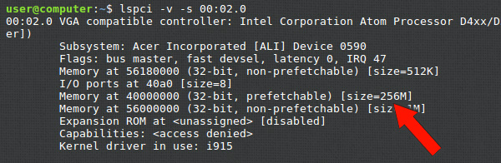  
     
   In this example, there is 256 MB of video RAM.

## Windows and Android, using the utility CPU-Z

CPU-Z is a free utility for Windows and [Android](https://www.computerhope.com/jargon/a/android.htm) that provides detailed system information, including the amount of video RAM. Follow the steps below to determine how much video memory your video adapter has.

1. [Download and install CPU-Z](http://www.cpuid.com/softwares/cpu-z.html)
2. Open CPU-Z.
3. Click the **Graphics** tab.
4. Locate the **Memory** section. The amount of video memory is displayed next to **Size**, as shown in the image below.

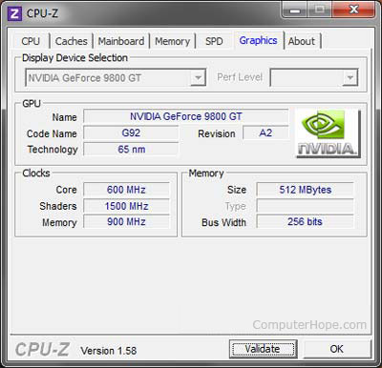

**Result**

The Determine the video memory size on your PC/Laptop is executed successfully.

EX:NO:3 Demonstrate the Bresenham’s Line drawing Algorithm.

Aim:

To Demonstrate the Bresenham’s Line drawing Algorithm.

Principles:

## ****Line Drawing Algorithms-****

In computer graphics, popular algorithms used to generate lines are-

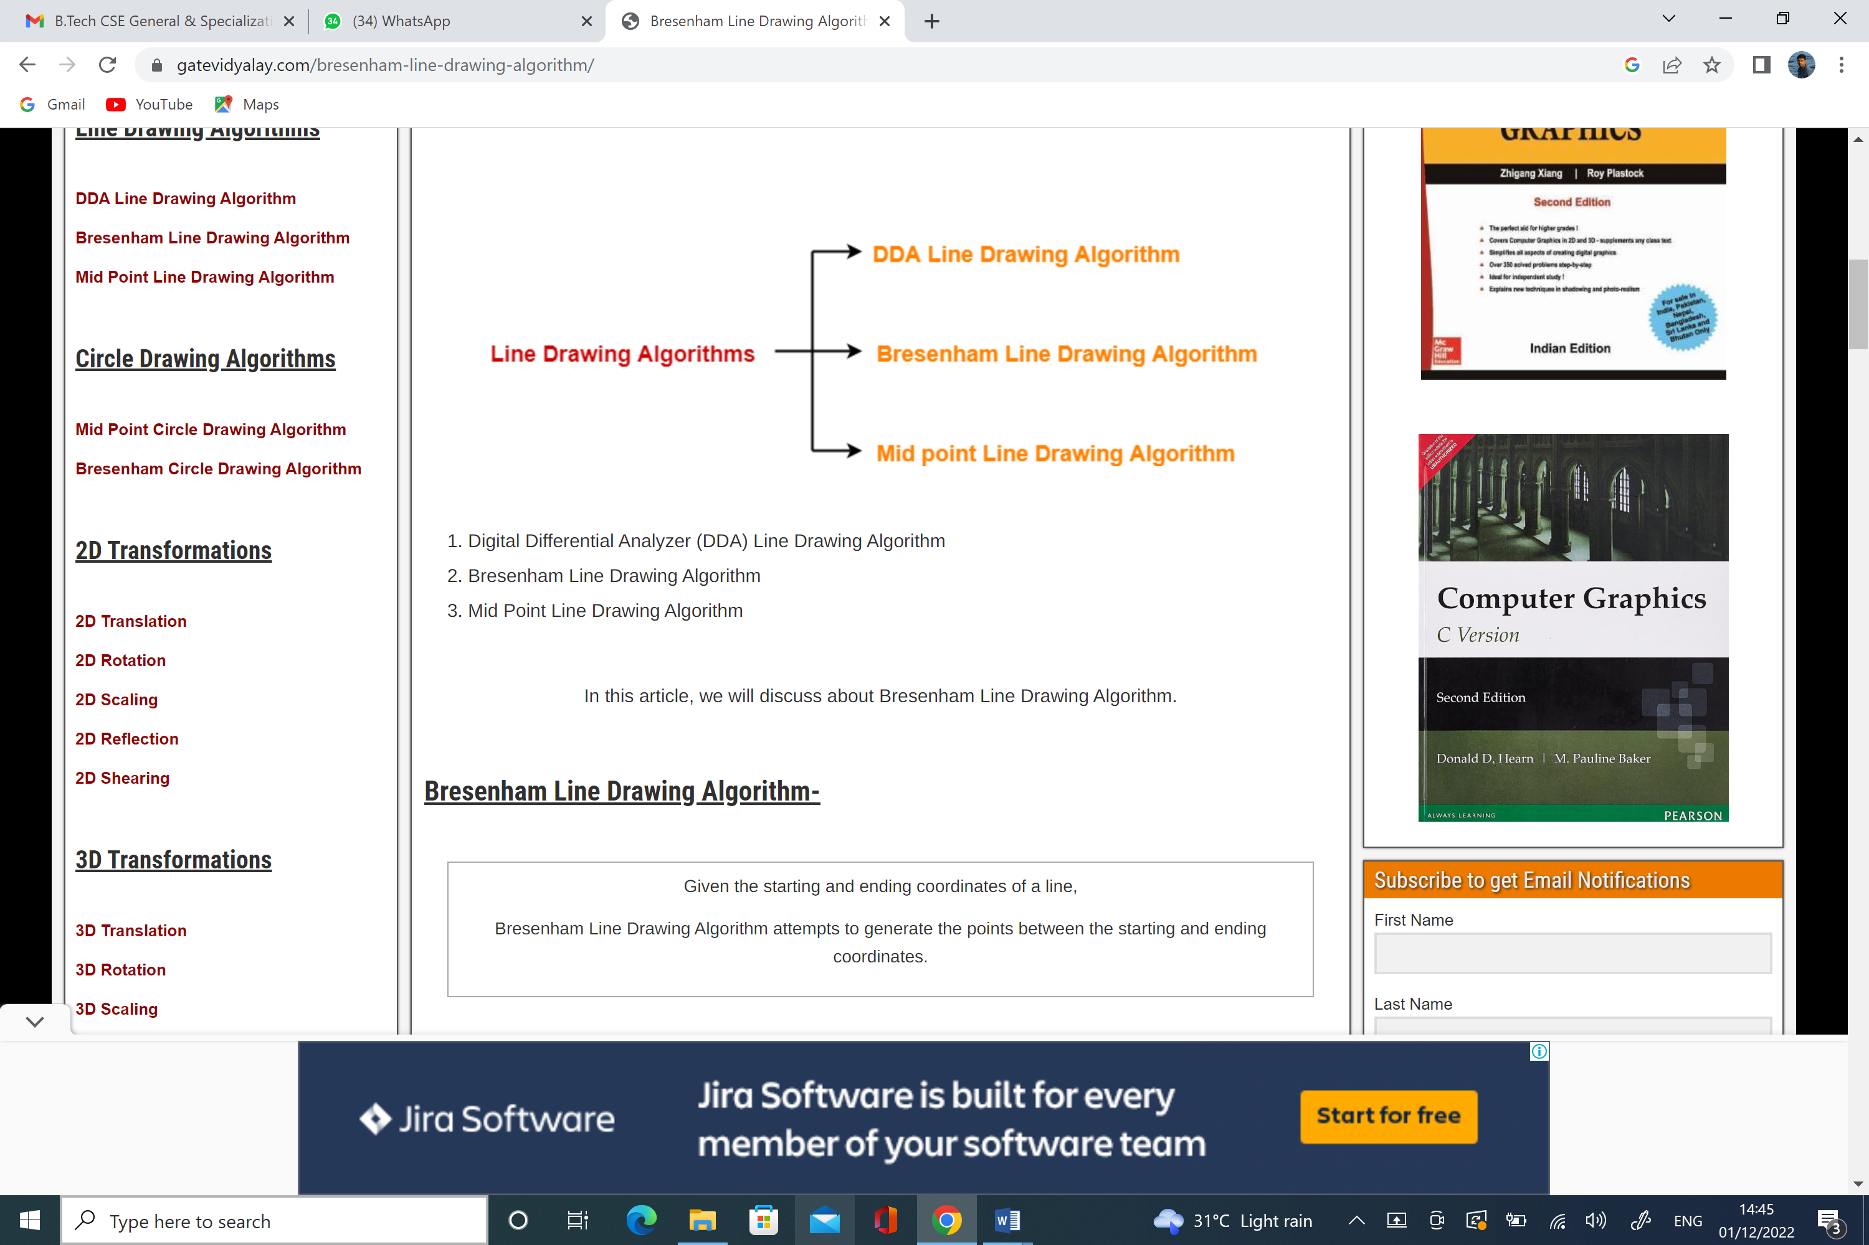

1. Digital Differential Analyzer (DDA) Line Drawing Algorithm
2. Bresenham Line Drawing Algorithm
3. Mid Point Line Drawing Algorithm

In this article, we will discuss about Bresenham Line Drawing Algorithm.

## ****Bresenham Line Drawing Algorithm-****

|  |
| --- |
| Given the starting and ending coordinates of a line,  Bresenham Line Drawing Algorithm attempts to generate the points between the starting and ending coordinates. |

### **Procedure-**

Given-

* Starting coordinates = (X0, Y0)
* Ending coordinates = (Xn, Yn)

The points generation using Bresenham Line Drawing Algorithm involves the following steps-

### **Step-01:**

Calculate ΔX and ΔY from the given input.

These parameters are calculated as-

* ΔX = Xn – X0
* ΔY =Yn – Y0

### **Step-02:**

Calculate the decision parameter Pk.

It is calculated as-

### **Step-03:**

Suppose the current point is (Xk, Yk) and the next point is (Xk+1, Yk+1).

Find the next point depending on the value of decision parameter Pk.

Follow the below two cases-

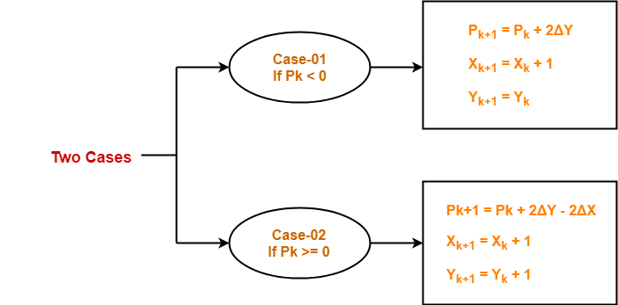

### **Step-04:**

Keep repeating Step-03 until the end point is reached or number of iterations equals to (ΔX-1) times.

## ****PRACTICE PROBLEMS BASED ON BRESENHAM LINE DRAWING ALGORITHM-****

## ****Problem-01:****

Calculate the points between the starting coordinates (9, 18) and ending coordinates (14, 22).

## ****Solution-****

Given-

* Starting coordinates = (X0, Y0) = (9, 18)
* Ending coordinates = (Xn, Yn) = (14, 22)

### **Step-01:**

Calculate ΔX and ΔY from the given input.

* ΔX = Xn – X0 = 14 – 9 = 5
* ΔY =Yn – Y0 = 22 – 18 = 4

### **Step-02:**

Calculate the decision parameter.

Pk

= 2ΔY – ΔX

= 2 x 4 – 5

= 3

So, decision parameter Pk = 3

### **Step-03:**

As Pk >= 0, so case-02 is satisfied.

Thus,

* Pk+1 = Pk + 2ΔY – 2ΔX = 3 + (2 x 4) – (2 x 5) = 1
* Xk+1 = Xk + 1 = 9 + 1 = 10
* Yk+1 = Yk + 1 = 18 + 1 = 19

Similarly, Step-03 is executed until the end point is reached or number of iterations equals to 4 times.

(Number of iterations = ΔX – 1 = 5 – 1 = 4)

|  |  |  |  |
| --- | --- | --- | --- |
| **Pk** | **Pk+1** | **Xk+1** | **Yk+1** |
|  |  | 9 | 18 |
| 3 | 1 | 10 | 19 |
| 1 | -1 | 11 | 20 |
| -1 | 7 | 12 | 20 |
| 7 | 5 | 13 | 21 |
| 5 | 3 | 14 | 22 |

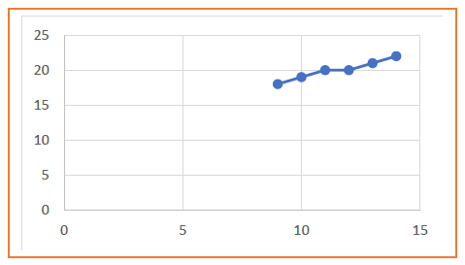

**Result**

The Demonstrate the Bresenham’s Line drawing Algorithm is experimental successfully.

**EX. NO: 4 Use understanding of the concept of colour theory to link the components that contribute to the effects of colour.**

AIM:

To Use understanding of the concept of colour theory to link the components that contribute to the effects of colour.

## Warm Colors [#](https://www.smashingmagazine.com/2010/01/color-theory-for-designers-part-1-the-meaning-of-color/#warm-colors)



Warm colors include red, orange, and yellow, and variations of those three colors. These are the colors of fire, of fall leaves, and of sunsets and sunrises, and are generally energizing, passionate, and positive.Red and yellow are both primary colors, with orange falling in the middle (making it a secondary color), which means warm colors are all truly warm and aren’t created by combining a warm color with a cool color. Use warm colors in your designs to reflect passion, happiness, enthusiasm, and energy.

### RED (PRIMARY COLOR) [#](https://www.smashingmagazine.com/2010/01/color-theory-for-designers-part-1-the-meaning-of-color/#red-primary-color)



Red is a very hot color. It’s associated with fire, violence, and warfare. It’s also associated with love and passion. In history, it’s been associated with both the Devil and Cupid. Red can actually have a physical effect on people, raising blood pressure and respiration rates. It’s been shown to enhance human metabolism, too.

Red can be associated with anger, but is also associated with importance (think of the red carpet at awards shows and celebrity events). Red also indicates danger (the reason stop lights and signs are red, and that warning labels are often red).

### ORANGE (SECONDARY COLOR) [#](https://www.smashingmagazine.com/2010/01/color-theory-for-designers-part-1-the-meaning-of-color/#orange-secondary-color)



Orange is a very vibrant and energetic color. In its muted forms it can be associated with the earth and with autumn. Because of its association with the changing seasons, orange can represent change and movement in general. Orange is also strongly associated with creativity.

### YELLOW (PRIMARY COLOR) [#](https://www.smashingmagazine.com/2010/01/color-theory-for-designers-part-1-the-meaning-of-color/#yellow-primary-color)



Yellow is often considered the brightest and most energizing of the warm colors. It’s associated with happiness and sunshine. Yellow can also be associated with deceit and cowardice, though (calling someone yellow is calling them a coward).

Yellow is also associated with hope, as can be seen in some countries when yellow ribbons are displayed by families who have loved ones at war. Yellow is also associated with danger, though not as strongly as red.

### BLUE (PRIMARY COLOR) [#](https://www.smashingmagazine.com/2010/01/color-theory-for-designers-part-1-the-meaning-of-color/#blue-primary-color)



Blue is often associated with sadness in the English language. Blue is also used extensively to represent calmness and responsibility. Light blues can be refreshing and friendly. Dark blues are more strong and reliable. Blue is also associated with peace and has spiritual and religious connotations in many cultures and traditions (for example, the Virgin Mary is generally depicted wearing blue robes).

### PURPLE (SECONDARY COLOR) [#](https://www.smashingmagazine.com/2010/01/color-theory-for-designers-part-1-the-meaning-of-color/#purple-secondary-color)



In ancient times, the dyes used for creating purple hues were extracted from snails and were very expensive, so only royals and the very wealthy could afford them.

Purple is a combination of red and blue and takes on some attributes of both. It’s associated with creativity and imagination, too.

### BLACK [#](https://www.smashingmagazine.com/2010/01/color-theory-for-designers-part-1-the-meaning-of-color/#black)



Black is the strongest of the neutral colors. On the positive side, it’s commonly associated with power, elegance, and formality. On the negative side, it can be associated with evil, death, and mystery. Black is the traditional color of mourning in many Western countries. It’s also associated with rebellion in some cultures, and is associated with Halloween and the occult.Black, when used as more than an accent or for text, is commonly used in edgier designs, as well as in very elegant designs. It can be either conservative or modern, traditional or unconventional, depending on the colors it’s combined with. In design, black is commonly used for typography and other functional parts, because of its neutrality. Black can make it easier to convey a sense of sophistication and mystery in a design.

### GRAY [#](https://www.smashingmagazine.com/2010/01/color-theory-for-designers-part-1-the-meaning-of-color/#gray)



Gray is a neutral color, generally considered on the cool end of the color spectrum. It can sometimes be considered moody or depressing. Light grays can be used in place of white in some designs, and dark grays can be used in place of black.

Gray is generally conservative and formal, but can also be modern. It is sometimes considered a color of mourning. It’s commonly used in corporate designs, where formality and professionalism are key. It can be a very sophisticated color. Pure grays are shades of black, though other grays may have blue or brown hues mixed in. In design, gray backgrounds are very common, as is gray typography.

**Result**

The Use understanding of the concept of colour theory to link the components that contribute to the effects of colour is experimental successfully.

**Ex:No : 5 To study the components and internal parts, working of hard disk and CDROM, DVD, Flash Drives**

**Aim**

To study the components and internal parts, working of hard disk and CDROM, DVD, Flash Drives

**hard disk drive**

Hard disk drives are [non-volatile](https://www.computerscience.gcse.guru/glossary/non-volatile) [magnetic storage](https://www.computerscience.gcse.guru/glossary/magnetic-storage) devices capable of remembering vast amounts of data. An electromagnet in the read/write head charges the disk’s surface with either a positive or negative charge, this is how [binary](https://www.computerscience.gcse.guru/glossary/binary) 1 or 0 is represented.The read/write head is then capable of detecting the magnetic charges left on the disk’s surface, this is how data is read. The disk surface is divided into concentric circles (tracks) and sectors (wedges).  Dividing the surface in this way provides physical addresses to remember where data is saved.A circuit board carefully co-ordinates the rotating disk and swinging [actuator](https://www.computerscience.gcse.guru/glossary/actuator) arm to allow the read/write head to access any location very quickly.Typical [HDD](https://www.computerscience.gcse.guru/glossary/hard-disk-drive) capacities are measured in Terabytes (TB).They can be installed inside a computer or purchased in a portable (external) format.

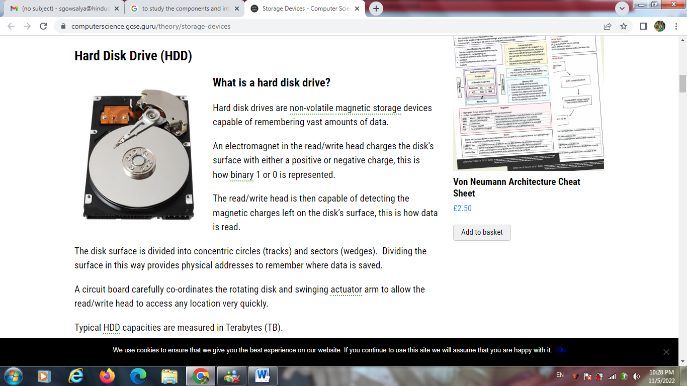

### **Typical applications for hard disk drives**

* Desktop computers
* Laptop computers
* TV and satellite recorders
* Servers and mainframes
* Portable (external) drives are sometimes used to backup home computers or transfer large files

### Benefits of hard disk drives

* Capable of holding vast amounts of data at affordable prices
* Fast read and write speeds
* Reliable technology
* Relatively small in size

# CD-ROM

**Compact Disc Read-Only Memory**, a **CD-ROM** is an [optical disc](https://www.computerhope.com/jargon/c/compactd.htm) containing audio or software data whose memory is [read-only](https://www.computerhope.com/jargon/r/readonly.htm). A **CD-ROM Drive** or **optical drive** is the device used to read them. CD-ROM drives have speeds ranging from 1x to 72x, meaning it reads the CD roughly 72 times faster than the 1x version. As you would imagine, these drives are capable of playing audio CDs and reading data CDs, including [CD-R](https://www.computerhope.com/jargon/c/cdr.htm) and [CD-RW](https://www.computerhope.com/jargon/r/rw.htm) discs.

## 

## Does my computer have a CD drive?

Today's newer computers no longer have [disc drives](https://www.computerhope.com/jargon/o/optidisc.htm) (CD drive). To determine if your computer has a CD drive, examine the front of the computer. The front of the computer should have a [slot](https://www.computerhope.com/jargon/s/slotcd.htm) or [tray](https://www.computerhope.com/jargon/t/tray.htm) that opens to read a CD. If you visually cannot see a CD drive, browse your computer drives to see if your operating system lists a disc drive.

* [How to see all drives available on the computer.](https://www.computerhope.com/issues/ch000854.htm)

If you see no disc drive, your computer doesn't have a CD drive. However, a CD drive can be installed into a [desktop computer](https://www.computerhope.com/jargon/d/desktopc.htm), or an [external](https://www.computerhope.com/jargon/e/external.htm) CD drive can connect to a desktop or laptop.

* [How to install a CD, DVD, or another disc drive.](https://www.computerhope.com/issues/ch000415.htm)

## Disc drive overview

Below is a picture of the front and back of a standard [IDE](https://www.computerhope.com/jargon/i/ide.htm) [CD-RW](https://www.computerhope.com/jargon/r/rw.htm) disc drive from [Memorex](https://www.computerhope.com/comp/memorex.htm).

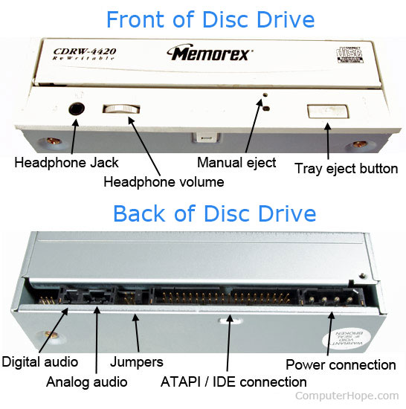

## How to open and close a CD-ROM drive

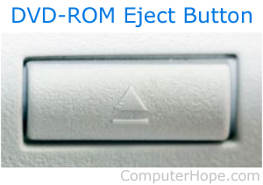

A CD-ROM drive can be opened by pressing the tray [eject button](https://www.computerhope.com/jargon/e/eject.htm) on the front of the drive (pictured right). To close the CD-ROM drive, press the tray or the eject button again.

If the eject button is not working, you can open or eject the tray through [My Computer](https://www.computerhope.com/jargon/m/mycomput.htm), or "This PC" in newer versions of Windows. In My Computer, find the list of drives in the computer, then right-click the CD-ROM drive and select **Eject** in the pop-up menu.

A CD-ROM drive can also be manually opened by inserting the end of the paperclip into the drive eject hole. Insert it gently until you feel resistance, then press in a little further to activate the release mechanism. If done properly, the tray should open a little bit, and you can use your fingers to pull the tray out gently. Manually opening or ejecting the tray can be useful for removing a CD that is stuck in the CD-ROM drive.

## CD-ROM and disc drive interfaces

Below are the different interfaces that allow a CD-ROM and other disc drives to connect to a computer.

* [**IDE/ATA**](https://www.computerhope.com/jargon/i/ide.htm) - One of the most commonly used interfaces for disc drives.
* **Panasonic** - Older proprietary interface.
* [**Parallel**](https://www.computerhope.com/jargon/p/paraport.htm) - Interface used with old external CD-ROM drives.
* [**PCMCIA**](https://www.computerhope.com/jargon/p/pcmcia.htm) ([**PC Card**](https://www.computerhope.com/jargon/p/pccard.htm)) - Interface sometimes used to connect external disc drives to [laptop](https://www.computerhope.com/jargon/l/laptop.htm) computers.
* [**SATA**](https://www.computerhope.com/jargon/s/sata.htm) - Replacing IDE as the new standard to connect disc drives.
* [**SCSI**](https://www.computerhope.com/jargon/s/scsi.htm) - Another common interface used with disk and disc drives.
* [**USB**](https://www.computerhope.com/jargon/u/usb.htm) - Interface most commonly used to connect external disc drives.

## DVD

Despite being the same physical size, a DVD can hold more data than a CD.

To achieve this, a more tightly packed spiral track is used to store the data on the disc.

To accurately access the smaller ‘bumps’, a finer red laser is used in a DVD drive than that found in a standard CD drive.

To increase capacity further, DVDs are also capable of dual layering.

# Flash Drive

 USB flash drives and their components might as well be magic. You plug a flash drive in, it helps you transfer your data, you forget about it until you need it again -- that's all you really need, after all.

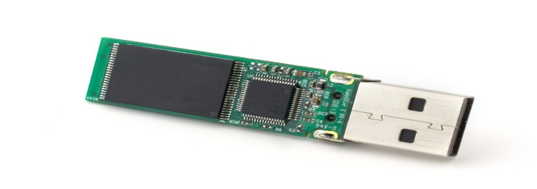

Every USB flash drive has five key components that are essential for its function. Here they are:

1. Outer Cover
2. Connector Plug
3. NAND Flash Memory Chip
4. Mass Storage Controller Chip
5. Crystal Oscillator

1. Outer Cover

The outer cover is one of the two parts of a USB flash drive that the average person sees. It's typically made from metal or plastic, although other materials like [wooden flash drives](https://www.usbmemorydirect.com/categories/wood.htm) aren't unheard of. As long as the cover does its job of protecting the internal components, it can look like almost anything, which is why our [custom USB drive](https://www.usbmemorydirect.com/) offerings are so popular.

2. Connector Plug

The other USB flash drive component that you're probably familiar with is the connector plug. This is the metal part that plugs into your device, and the one you [probably insert upside down](https://www.usbmemorydirect.com/blog/heres-why-you-never-plug-in-a-usb-right-the-first-time/) the first time you try to plug it in. For many years, almost all USB drives have used a standard USB-A connector, but they're increasingly moving to the sleeker and faster [USB-C connector](https://www.usbmemorydirect.com/blog/usb-a-vs-usb-c/).

3. NAND Flash Memory Chip

Every USB flash drive has a NAND flash memory chip that it uses to store data. When you load documents, photos, videos, applications, or anything else onto a flash drive, the drive stores it on the flash memory chip. NAND flash memory is the standard today because it's much more durable than older optical media, and it's now also extremely inexpensive.

### 4. Mass Storage Controller Chip

Your USB drive needs an intermediary to help it communicate with the device that it's plugged into, and that's where the mass storage controller chip comes in. This chip acts as the go-between, allowing the host device user to access and change the files stored on the USB drive.

### 5. Crystal Oscillator

Finally, we have the [crystal oscillator](https://www.electronics-tutorials.ws/oscillator/crystal.html), which functions as a tiny clock inside your USB drive. It regulates the timing of all the other electronic components and helps them work together by providing steady timekeeping.

**Result**

The components and internal parts, working of hard disk and CDROM, DVD, Flash Drives is experimental successfully.

EX:NO: 6 Familiarize with the computer system Layout: Mark positions of SMPS, Motherboard, processor, cooling systems, HDD, SSD RAM, Graphics unit and add on cards.

AIM:

To Familiarize with the computer system Layout: Mark positions of SMPS, Motherboard, processor, cooling systems, HDD, SSD RAM, Graphics unit and add on cards.

WORKING:

A **motherboard** contains a socket into which one or more processors can be attached. It has slots for peripheral cards such as video cards, sound cards or networking cards. It includes a chipset that acts as an interface between all of a computers subsystems. It holds the **ROM** or permanent memory used by the **BIOS** (Basic Input/Output System) -- a bit of memory that doesn't get erased when the computer is turned off because it contains the instructions that reminds the computer what to do when it gets turned back on. In addition, a motherboard includes a clock generator that is a sort of electronic metronome that the computer uses to synchronize various operations. It also holds the more active memory **RAM** that the machine uses when it runs software. Finally, the motherboard has slots for expansion cards and power connectors which provide power to various components (high speed graphics cards and disk drives get their power directly from the power supply).

Board Layout

shows the location of the major components on Intel Desktop Board DH61WW.

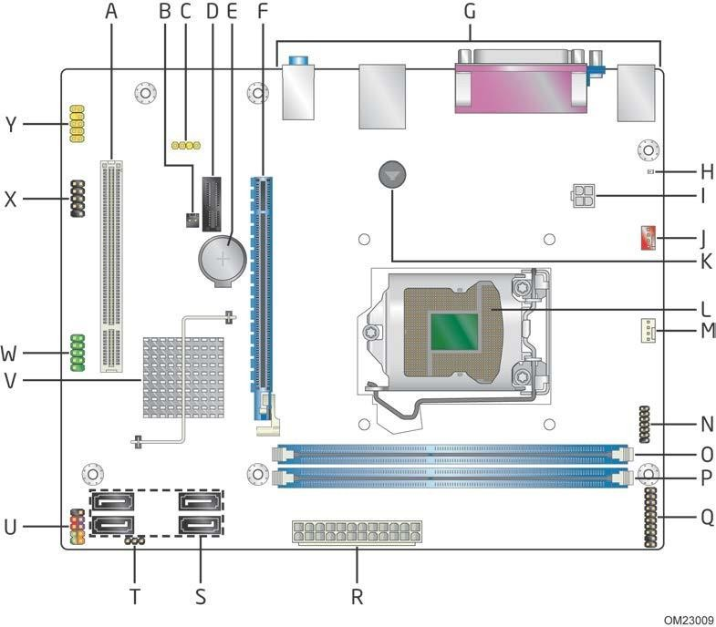

Intel® Desktop Board DH61WW

Board Components

|  |  |
| --- | --- |
| **Item/callout from Figure** | **Description** |
| A | Conventional PCI bus add-in card connector |
| B | Chassis intrusion header |
| C | S/PDIF header |
| D | PCI Express x1 add-in card connector |
| E | Battery |
| F | PCI Express x16 add-in card connector |
| G | Back panel connectors |
| H | Standby power LED |
| I | 12 V internal power connector (ATX12V) |
| J | Rear chassis fan header |
| K | Piezoelectric speaker |
| L | LGA1155 processor socket |
| M | Processor fan header |
| N | Low Pin Count (LPC) Debug header |
| O | DIMM 1 (Channel A DIMM 1) |
| P | DIMM 2 (Channel B DIMM 1) |
| Q | Trusted Platform Module (TPM) header |
| R | Main power connector (2 x 12) |
| S | SATA connectors |
| T | BIOS setup configuration jumper block |
| U | Front panel header |
| V | Intel H61 Express Chipset |
| W | Serial port header |
| X | Front panel USB 2.0 headers |
| Y | Front panel audio header |

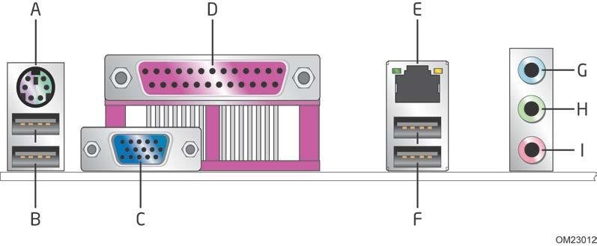**Back Panel Connectors**

|  |  |
| --- | --- |
| **Item** | **Description** |
| **A** | PS/2 keyboard/mouse connector |
| **B** | USB 2.0 ports |
| **C** | VGA connector |
| **D** | Parallel port |
| **E** | LAN |
| **F** | USB 2.0 ports |
| **G** | Line in |
| **H** | Line out/front speakers |
| **I** | Mic in/side surround |

# Front Panel Header

### Hard Drive Activity LED Header

Pins **1** and **3** can be connected to an LED to provide a visual indicator that data is being read from or written to an internal storage device. Proper LED function requiresa SATA hard drive or optical drive connected to an onboard SATA connector.

### Reset Switch Header

Pins **5** and **7** can be connected to a momentary single pole, single throw (SPST) type switch that is normally open. When the switch is closed, the board resets and runs thePOST.

### Power LED Header

Pins **2** and **4** can be connected to a one- or two-color LED. Table 23 shows the defaultstates for this LED. More options are available through BIOS setup.

### Power Switch Header

Pins **6** and **8** can be connected to a front panel momentary-contact power switch. Theswitch must pull the SW_ON# pin to ground for at least 50 ms to signal the power supply to switch on or off. (The time requirement is due to internal debounce circuitryon the board.) At least two seconds must pass before the power supply will recognizeanother on/off signal.

# PROCESSOR

The processor is a chip or a logical circuit that responds and processes the basic instructions to drive a particular computer. The main functions of the processor are fetching, decoding, executing, and write back the operations of an instruction. The processor is also called the brain of any system which incorporates computers, laptops, smartphones, embedded systems, etc. The ALU (Arithmetic Logic Unit) and CU (Control Unit) are the two parts of the processors. The Arithmetic Logic Unit performs all mathematical operations such as additions, multiplications, subtractions, divisions, etc and the control unit works like traffic police, it manages the command or the operation of the instructions. The processor communicates with the other components also they are input/output devices and memory/storage devices.

# Comparing CPUs

In addition to the brand name and model of a CPU, there are stats that you can use to compare different processing chips.

The most commonly cited statistic about a CPU is its clock speed, which refers to how many program instructions it can run in a second. This speed is typically measured in megahertz or gigahertz.

Another important measurement for comparing CPUs is the number of cores in the chip. A core is an independent processor within a processor that can run commands in parallel with other cores. There's a limit to how much software can be divided into units of commands that can run simultaneously, so adding additional cores only speeds up computers some, but in general, CPUs with more cores run faster than those with fewer cores.

Depending on your needs, you may want to look at the power consumption of a particular CPU. Faster CPUs sometimes use more energy than slower ones, but computers have become more efficient over time

# Intel® Core™ processor series

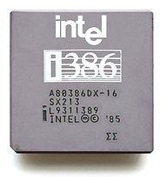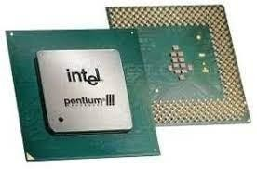

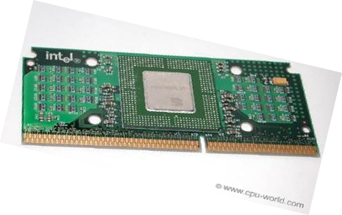

**1985 1998 1999**

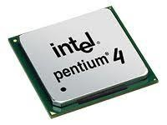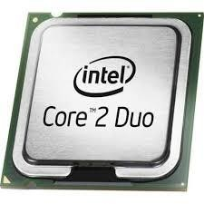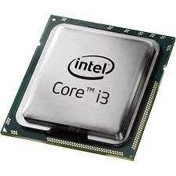

## 2000 2006 2010

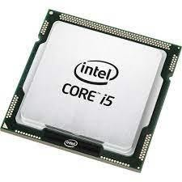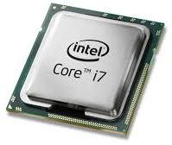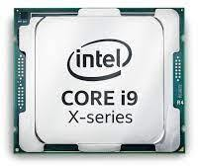

**2009 2008 2017**

# RAM

Random access memory (RAM) is a type of data storage used in computers that is generally located on the [motherboard](https://www.techopedia.com/definition/2876/motherboard). It is the main memory used by a computer for quick access since is much faster to read and write than other forms of storage—between 20-100 times faster than hard disks.

Each storage location inside the memory can be accessed independently of the address, meaning that every location can be reached easily at the same time (hence the term “random”). RAM is a volatile type of memory, meaning that all information that was stored in RAM is lost when the computer is turned off.

# TYPES OF RAM

**DDR RAM - Double Data Rate Synchronous DRAM**: A clock is used to read data from a DRAM. DDR memory reads data on both the rising and falling edge of the clock, achieving a faster data rate. Often used in notebook computers because it also consumes less power.

**DDR1 RAM -** Launched in 2000, it did not start to be used until almost 2002. It operated at 2.5V and 2.6V, and its maximum density was 128 Mb (so there were no modules with more than 1 GB) with a speed of 266 MT/s (100-200 MHz).

**DDR2 RAM**

Released around 2004, it ran at 1.8 volts, 28% less than DDR1. Its maximum density was doubled to 256 Mb (2 GB per module). Logically, the maximum speed also multiplied, reaching 533 MHz.

##### DDR3 RAM

This release occurred in 2007, and it was a revolution because XMP profiles were implemented here. To begin with, the memory modules operated at 1.5V and 1.65V, with base speeds of 1066 MHz, but that went much further, and the density reached up to 8 GB per module.

***DDR4 RAM***

This did not arrive until 2014, but today it is already the most widespread. The voltage is reduced to 1.05 and 1.2V, although many modules operate at 1.35V. The speed has been notably increased, and each time faster memories are

released from the factory, but its base began at 2133 MHz. Currently, there are already 32 GB modules, but this is also being expanded little by little.

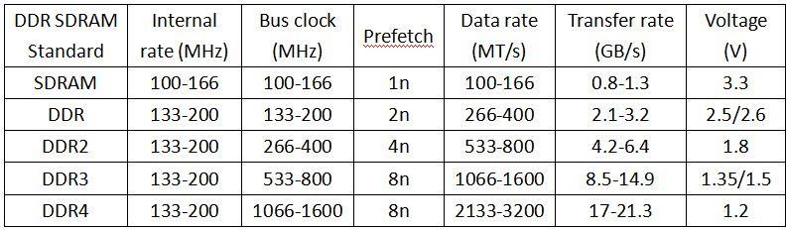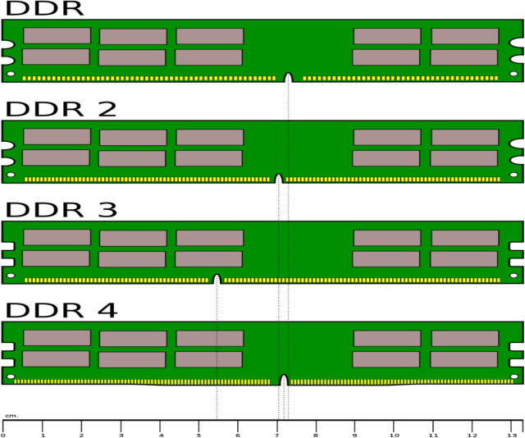

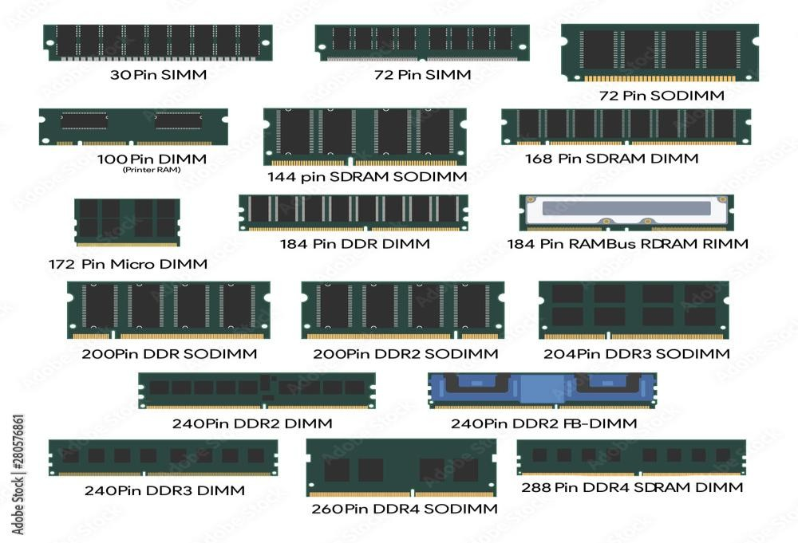

# HARD DISK

A [hard disk](https://www.javatpoint.com/hdd)

is also known as a hard drive or fixed disk. It is said to be rigid magnetic disc that stores data. It is located within a drive unit. Hard disk is a non-volatile storage device that contains platters and magnetic disks rotating at high speeds. Non- volatile means the data retains when the computer shuts down.

It is installed internally in our computer systems. Hard disk is located within a drive unit on the computer's motherboard and comprises one or more platters packed in an air-sealed casing.

Its main components include a read/write actuator arm, head actuator, read/write head, spindle, and platter. A circuit board (also called as the interface board or disk controller) is present on the back of a hard drive. It lets the hard drive to communicate with the computer.

# Function of Hard disk

The hard disk is a secondary storage device, which is designed to store data permanently. The secondary storage devices include a large storage capacity as compared to the primary storage devices. The data stored in a hard disk is retained when our computer system shuts down. The data stored in the hard disk can be of many types such as the operating system, installed software, documents, and other files of computer.

Hard disk was introduced in the year 1956 by IBM. The first personal computer contains a hard drive of less than 1 megabyte, while modern computers contain a hard drive of 1 terabyte.

Every computer contains atleast one hard drive to store data and software. In Windows operating system, the hard drive is known to be the C drive, and in MAC, it is simply called as the hard drive. The desktop computers which have external hard drives are used for backup purposes or additional storage.

The size of hard drives is measured in gigabytes and terabytes. Usually, 500GB hard disks are common in modern computers. As an instance, a song of length four-minute is approx. 4MB in size, and in 1 gigabyte, there are 1,000 megabytes, it means that a 500GB hard drive can store approx. 250,000 songs.

# Advantages of the hard disk

* One of the significant advantages of a Hard Disk drive is that its cost is low.
* Hard Disk is faster than optical disks.
* The capacity for storing the data in HDDs is large.

# Disadvantages of the hard disk

* The speed of reading and writing in HDD is slower than the RAM.
* Another disadvantage of HDD is energy inefficiency.
* HDDs consume more power.
* The form factor of HDDs is heavier than the SSDs.

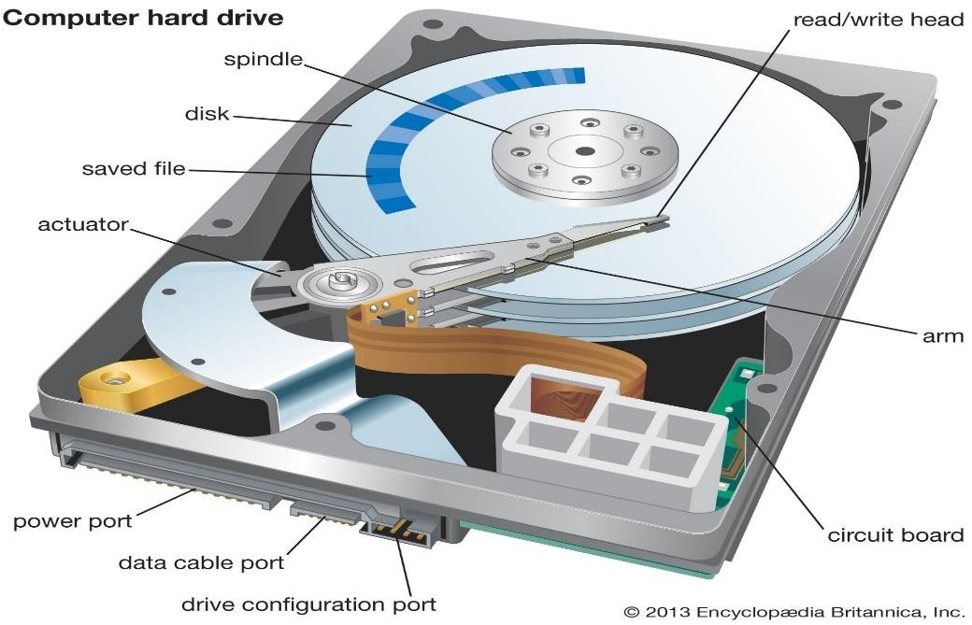

# SMPS- Switched Mode Power Supply

SMPS or switched mode power supply is an electronic device that is used to convert AC to DC, AC to AC, DC to DC, and DC to AC voltages. The circuit consists of a transformer, rectifier, voltage regulator, and filter. The input supply is turned On and Off by MOSFETs and outputs a high efficiency, regulated voltage. The SMPS used in computers is of AC to DC type supply.

# SMPS Parts and Connectors

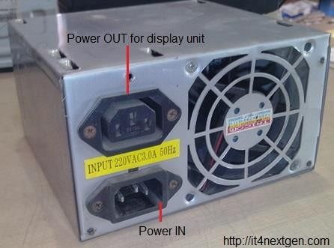

**Power-IN.** The power-IN connector as shown in the figure is the input for the MAINS supply. A power cable is inserted here, the other end of which is connected to the main supply. The input supply gets converted to DC supply.

**Power-OUT**. The power-OUT connector is connected directly to the Power-IN connector from inside the supply unit. It supplies the same AC supply that is fed to the power-IN socket. The power-OUT connector is used to give supply to monitors or any display unit.

**FAN**. If you look at the back side of Computer-SMPS, you will find a FAN on the right side. The FAN as you can see blows the air out and is only used to dissipate the internal heat from the SMPS since the switching is done at high frequencies which creates a lot of heat inside.

**ATX connector**. As you can see in the image, it is a 24-pin female connector that is used to supply DC supply to the motherboards. Various color-coded wires connect to this connector and each colored wire supplies a distinct DC voltage which is explained in the chart below.

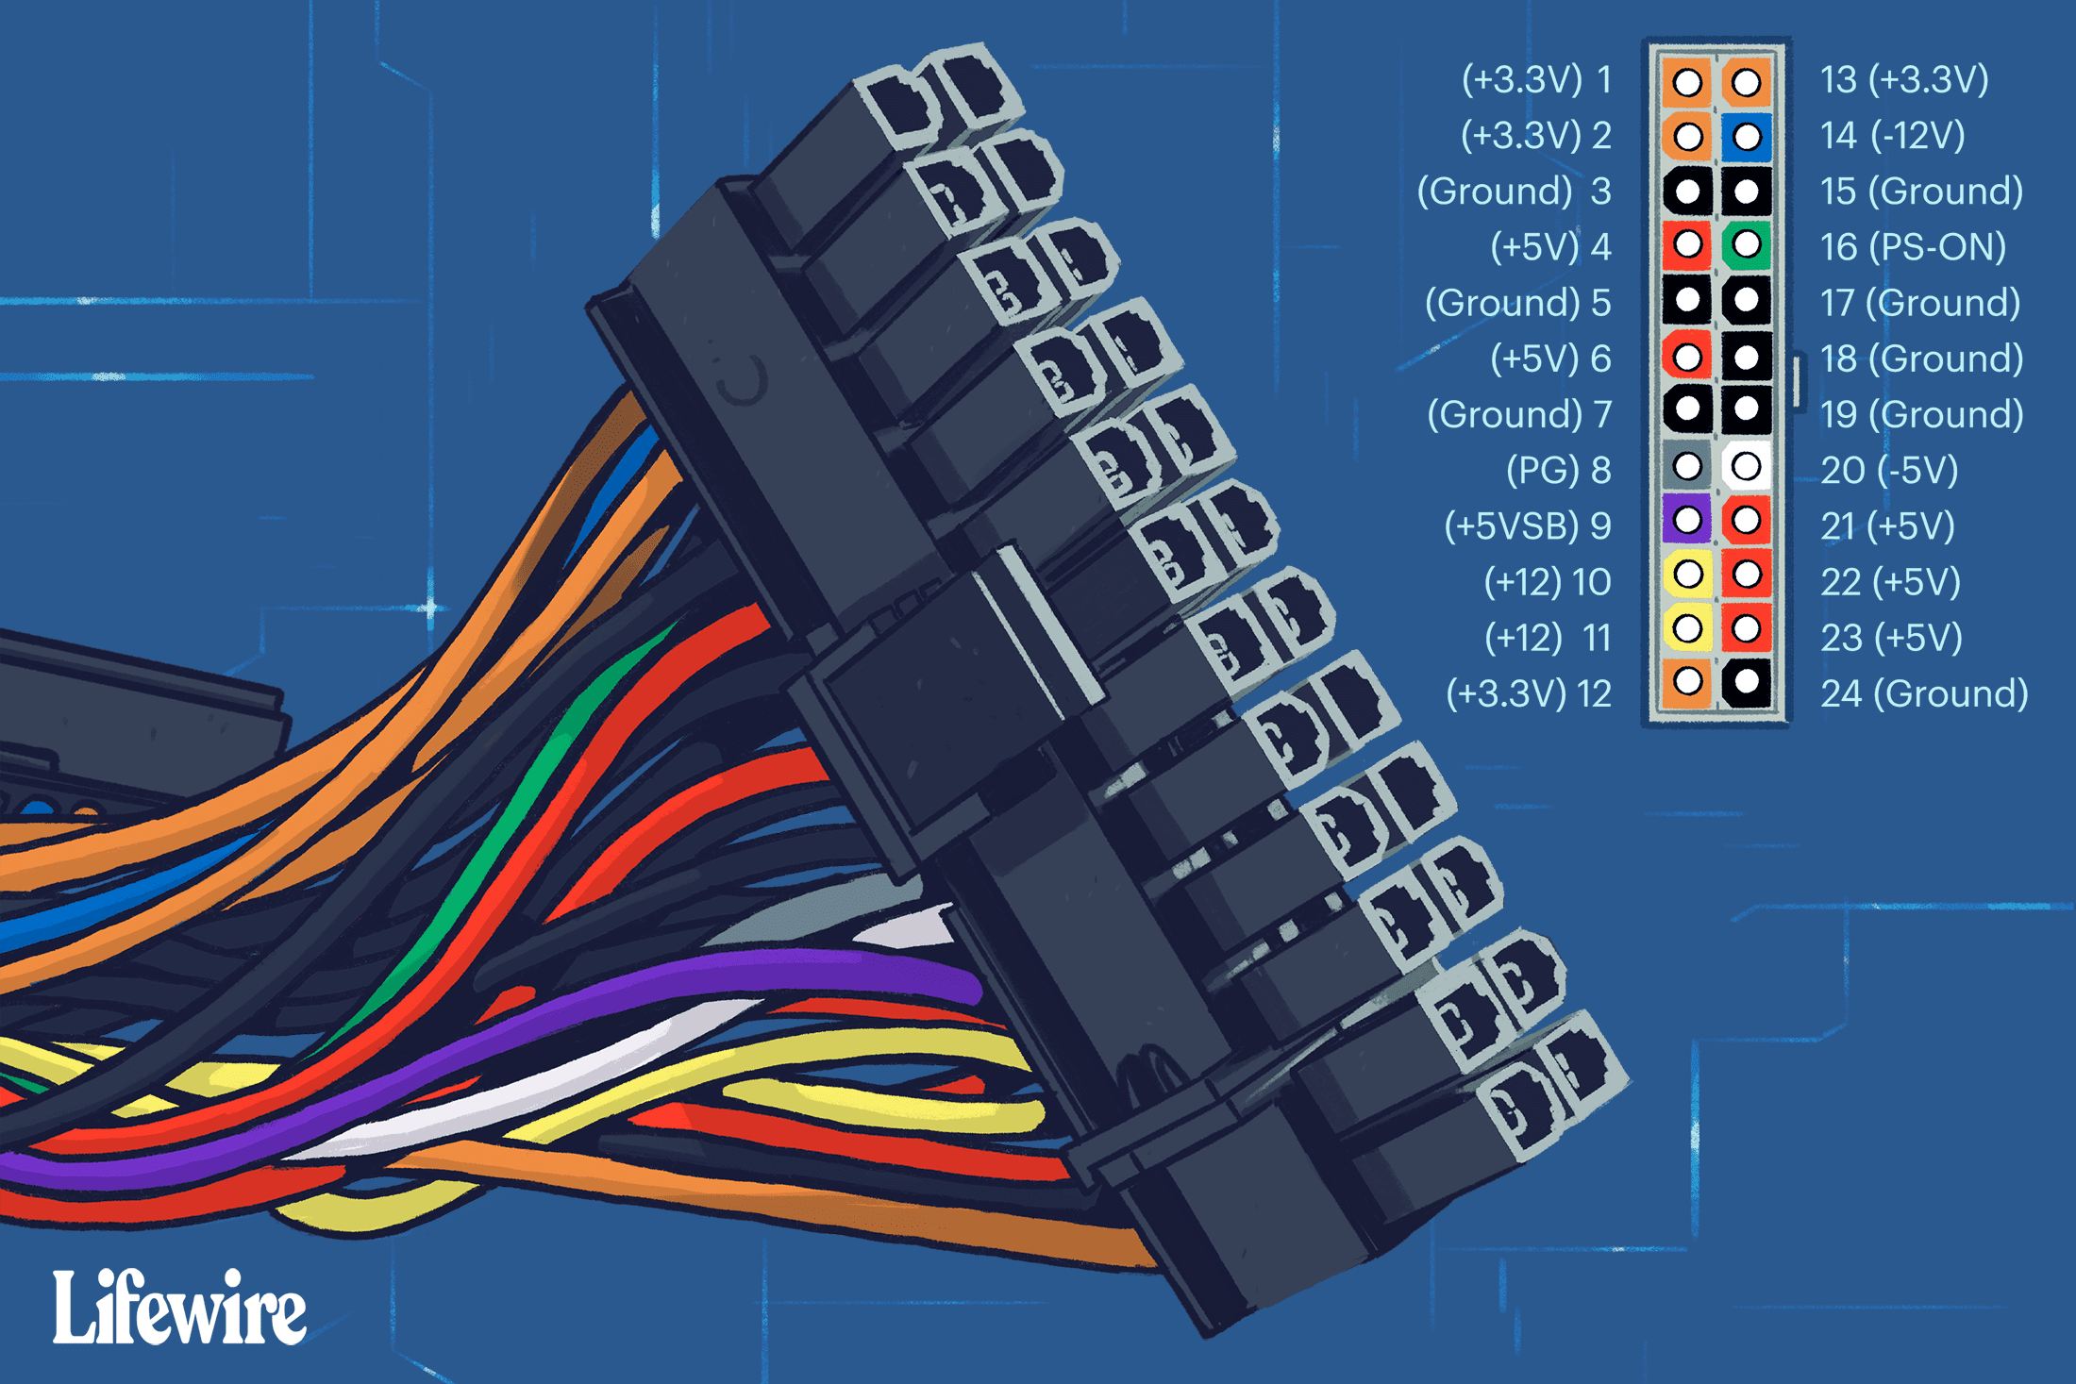

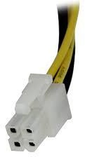

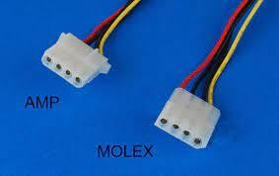**ATX-12V connector. The** Latest SMPS power supplies are accompanied by an extra 4-pin connechich supplies 12 volts to energize the central processing unit and ot

**4-PIN connectors.** There are multiple 4-pin connectors that draw out from the SPMS unit. These connectors are used to supply DC power to various peripherals of a computer like a floppy disk drive, hard disk drive, or DVD-writers.

|  |  |  |
| --- | --- | --- |
| **Wire Colour** | **DC Voltage** | **Used For** |
| Yellow | +12 V | Motors |
| Black | GND |  |
| Black | GND |  |
| Red | +5V | Logic circuit |

EXPERMENT 7

**DISSECTING THE MOTHERBOARD: CONNECTORS, PORTS AND CHIPSETS**

AIM

TO STUDY DISSECTING THE MOTHERBOARD: CONNECTORS, PORTS AND CHIPSETS

PRINCIPLES

Motherboard ports are the inputs or connection points where components plug into, including the rear ports at the back of a computer. If you’re replacing an internal hardware component or upgrading for better performance, you must remove the existing equipment from its dedicated motherboard port. To install new components, you do the opposite and plug the new component(s) into a dedicated port.

There are also external ports located on the rear of the motherboard, for plugging in and disconnecting peripherals. Without opening the case, you can plug a mouse, keyboard, or external hard drive into the top or rear USB ports, for instance.

There are several types of internal ports including PCI-e, SATA, CPU, and so on. There are also external ports like USB, PS/2, RJ-45, and beyond. Both are referred to as ports.

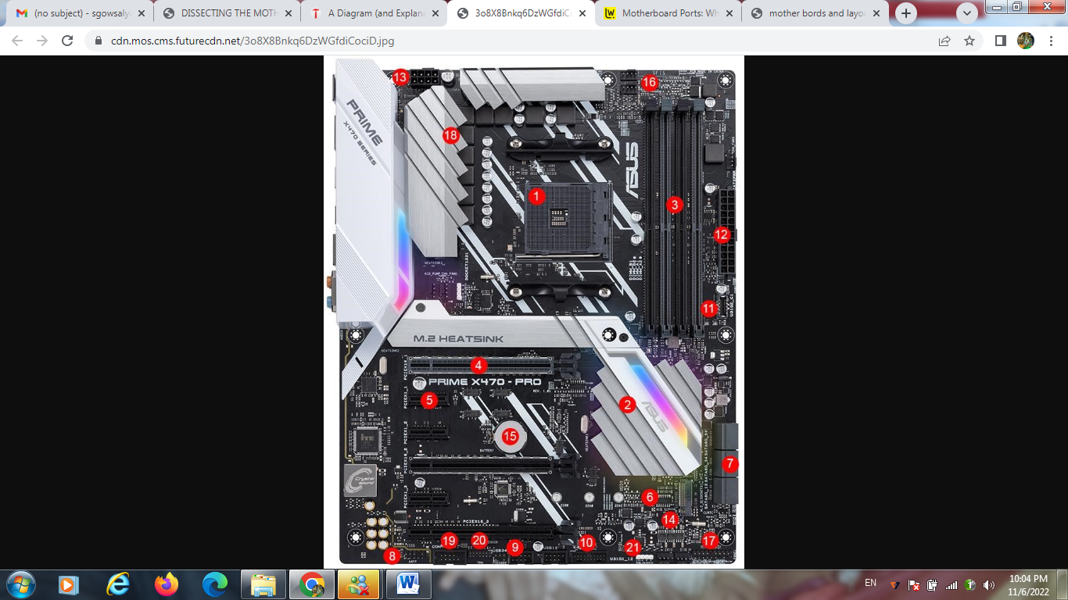

|  |  |  |
| --- | --- | --- |
| 1. CPU socket | 2. Chipset | 3. DIMM/RAM slots |
| 4. PCIe x16 slot | 5. PCI x1 slot | 6. M.2 connector |
| 7. SATA ports | 8. Front panel connectors | 9. USB 2. header |
| 10. USB 3.1 Gen1 header | 11. USB 3.1 Gen2 header | 12. ATX power connector |
| 13. CPU power connector | 14. BIOS chips | 15. CMOS battery |
| 16. Fan headers | 17. Front panel header | 18. VRM heatsink |
| 19. COM/Serial header | 20. TPM header | 21. RGB header |

Above we’ve illustrated many of the common motherboard port and connector types. Of course, not all boards feature all types, and things like fan headers, M.2 connectors, and the BIOS battery will be located in different spots on different boards.

WORKING

**Rear Ports**

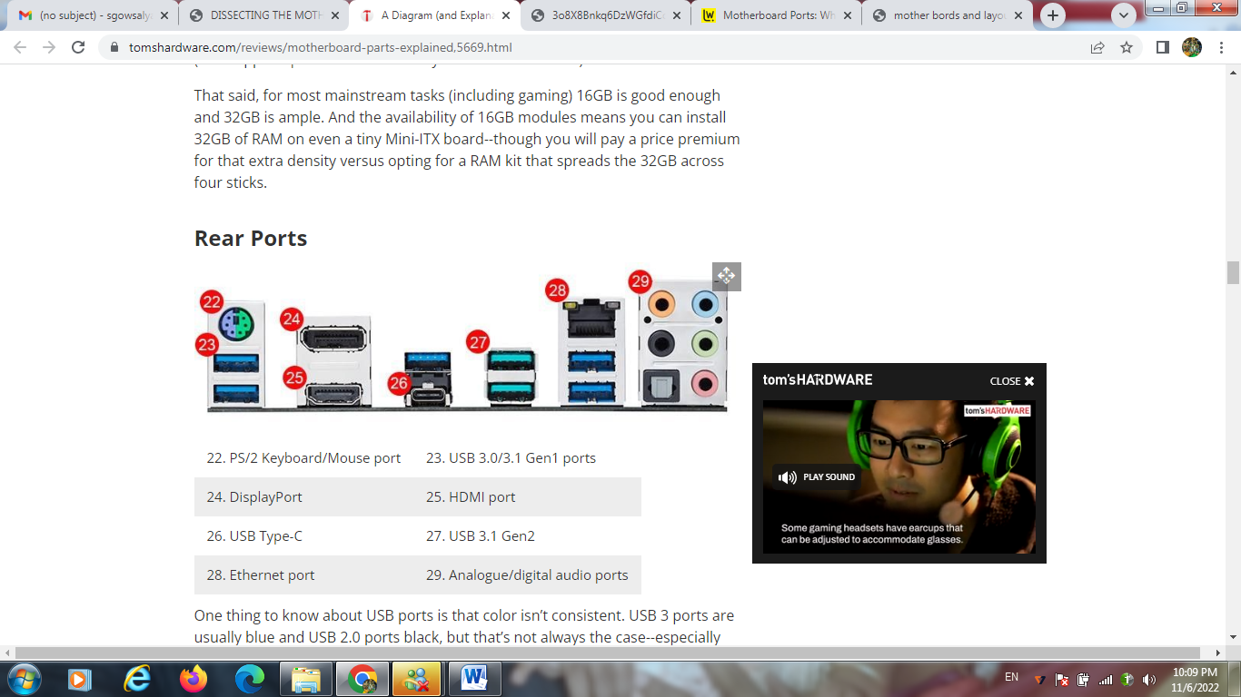

|  |  |
| --- | --- |
| 22. PS/2 Keyboard/Mouse port | 23. USB 3.0/3.1 Gen1 ports |
| 24. DisplayPort | 25. HDMI port |
| 26. USB Type-C | 27. USB 3.1 Gen2 |
| 28. Ethernet port | 29. Analogue/digital audio ports |

One thing to know about USB ports is that color isn’t consistent. USB 3 ports are usually blue and USB 2.0 ports black, but that’s not always the case--especially when board makers add feature like sleep-charge to some ports. Likewise, the USB 3.1 Gen2 ports on the board above are a blue-green shade, while MSI often makes its USB 3.1 Gen1 and Gen2 ports red.

Also note that, if you are planning on installing a dedicated graphics card, you likely won’t be using the on-board video ports. If that’s your aim, look for a board with fewer (or no) video ports, to make room for more USB or other ports.

**Chipset/Socket**

Another key board consideration is, of course, what CPU you need it to support. For all you need to know about choosing a processor, you can head to our [CPU buying guide](https://www.tomshardware.com/reviews/cpu-buying-guide,5643.html). But once you’ve settled on a CPU, you often still have chipset options which dictate things like how many high-speed components you can install, or how many super-fast USB ports are supported.

Since the chipset is arguably the main component that’s permanently attached to the motherboard (as opposed to removable CPU or RAM), we’ll list the primary features of each current-generation chipset below, to help you choose. But chipsets can be incredibly complex, enough so that a story could be written about each one. Along those lines, you can peruse the finer details of Intel’s latest mainstream H370 and B370 chipsets and boards in our [Cheap Coffee Lake feature](https://www.tomshardware.com/reviews/h370-b360-budget-coffee-lake-motherboard-roundup,5548.html). For feature details and comparisons of those and other current chipsets, you can check the charts below.

**AMD Chipsets**

|  |  |  |  |  |  |  |
| --- | --- | --- | --- | --- | --- | --- |
| **AMD** | **Chipset** | **PCI Express Graphics** | **USB 3.1 G2 + 3.1 G1 + 2.0** | **SATA + NVME** | **SATA RAID** | **SupportsOverclocking** |
| **Enthusiast** | X399 | 3x16+1x8, 2x16+3x8, 1x16+5x8 | 2+14+6 | 12 + 3 | 0,1, 10 | Yes |
| **Enthusiast** | X470 | 1x16/2x8 (AMD Ryzen processors) 1x8 (A-Series/AMD Athlon processors) | 2+10+6 | 6 + x2 NVMe (or 4 SATA plus 1 x4 NVMe on AMD Ryzen™ Processor) | 0,1,10 | Yes |
| **Enthusiast** | X370 | 1x16/2x8 (AMD Ryzen) 1x8 (A-Series/AMD Athlon) | 2+10+6 | 6 + x2 NVMe (or 4 SATA plus 1 x4 NVMe on AMD Ryzen™ Processor) | 0,1,10 | Yes |
| **Performance** | B350 | 1x16(AMD Ryzen)1x8 (A-Series/AMD Athlon) | 2+6+6 | 4 + x2 NVMe (or 2 SATA 1 x4 NVMe on AMD Ryzen™ Processor) | 0,1,10 | Yes |
| **Mainstream** | A320 | 1x16 (AMD Ryzen) 1x8 (A-Series/AMD Athlon) | 1+6+6 | 4 + x2 NVMe (or 2 SATA 1 x4 NVMe on AMD Ryzen™ Processor) | 0,1,10 | No |
| **SFF Options** | X300 | 1x16/2x8 (AMD Ryzen) 1x8 (A-Series/AMD Athlon) | 0+4+0 | 2 + x2 NVMe (or 1 x4 NVMe on AMD Ryzen™ Processor) | 0,1 | Yes |
|  | A300 | 1x16 (AMD Ryzen) 1x8 (A-Series/AMD Athlon) | 0+4+0 | 2 + x2 NVMe (or 1 x4 NVMe on AMD Ryzen™ Processor) | 0,1 | No |

**Intel Chipsets**

|  |  |  |  |  |  |  |
| --- | --- | --- | --- | --- | --- | --- |
| **Intel** | **Chipset** | **Supported Processor PCI Express Port Configurations** | **USB Revision** | **Max Number of SATA 6.0 Gb/s Ports** | **Intel Optane Memory Support** | **Supports Overclocking** |
| **Enthusiast** | X299 | Depends on CPU Model | 3.0/2.0 | 8 | Yes | Yes |
| **Enthusiast** | Z370 | 1x16 or 2x8 or 1x8+2x4 | 3.0/2.0 | 6 | Yes | Yes |
| **Mainstream** | H370 | 1x16 | 3.1/2.0 | 6 | Yes | No |
| **Mainstream** | Q370 | 1x16 or 2x8 or 1x8+2x4 | 3.1/2.0 | 6 | Yes | No |
| **Mainstream** | B360 | 1x16 | 3.1/2.0 | 6 | Yes | No |
| **Mainstream** | H310 | 1x16 | 3.1/2.0 | 4 | No | No |

One thing that’s important to note about chipset features: Just because something is supported by the chipset, doesn’t mean the motherboard maker has implemented it on a given board. For example, Intel’s Z370 chipset supports up to 10 USB 3.0 ports (and 14 in total), but most boards ship with 4-8 USB ports. And the newer H370 chipset features up to four faster USB 3.1 Gen2 ports, but the [Gigabyte H370N WiFi motherboard](https://www.tomshardware.com/reviews/gigabyte-h370n-wifi-mini-itx-coffee-lake-motherboard,5610.html) lacks any of those speedy next-gen ports.

**EXEPERIMENT NO:8**

**PERFORMANCE ANALYSIS OF COOLING SYSTEMS IN PCs (SETUP A BENCHMARK SOFTWARE -E.G: CINEBENCH TO PERFORM THIS), THEREBY WRITE THE NEED OF EFFICIENT COOLING SYSTEMS.**

**AIM**

To Performance Analysis Of Cooling Systems In Pcs (Setup A Benchmark Software -E.G: Cinebench To Perform This), Thereby Write The Need Of Efficient Cooling Systems.

**PROCEDURE**

Cinebench works in part using the code which forms part of Maxon’s 4D software to render a three-dimensional scene on your machine using advanced algorithms. This is them used to gauge the efficiency of your openGL and CPU settings.

Results are displayed using Cinebench’s own scoring system. In this guide, you’ll learn not only how to run basic and advanced tests on your computer but to see how it compares to other similar models. This is a great way for reviewers to make sure that new hardware lives up to the manufacturer’s claims, as well as for power users to check their system is still shipshape.

**WORKING**

**1. Download and run Cinebench**

Open you web browser and navigate [to the Cinebench website](https://www.maxon.net/en/products/cinebench/)(opens in new tab). Click the download link for your own operating system e.g. Cinebench for Mac.

If you’re using Windows, Cinebench is compressed in ZIP format. Right-click and choose ‘Extract All’ to access the program itself. The macOS version of Cinebench is stored inside a DMG container. Once the download is complete, double-click to mount.

Cinebench can be run directly from your downloads folder regardless of which operating system you use but you can copy the utility to your ‘Program Files’ or ‘Applications’ folder if you wish. Double-click to launch.

Open the folder named Cinebench and then click to launch.

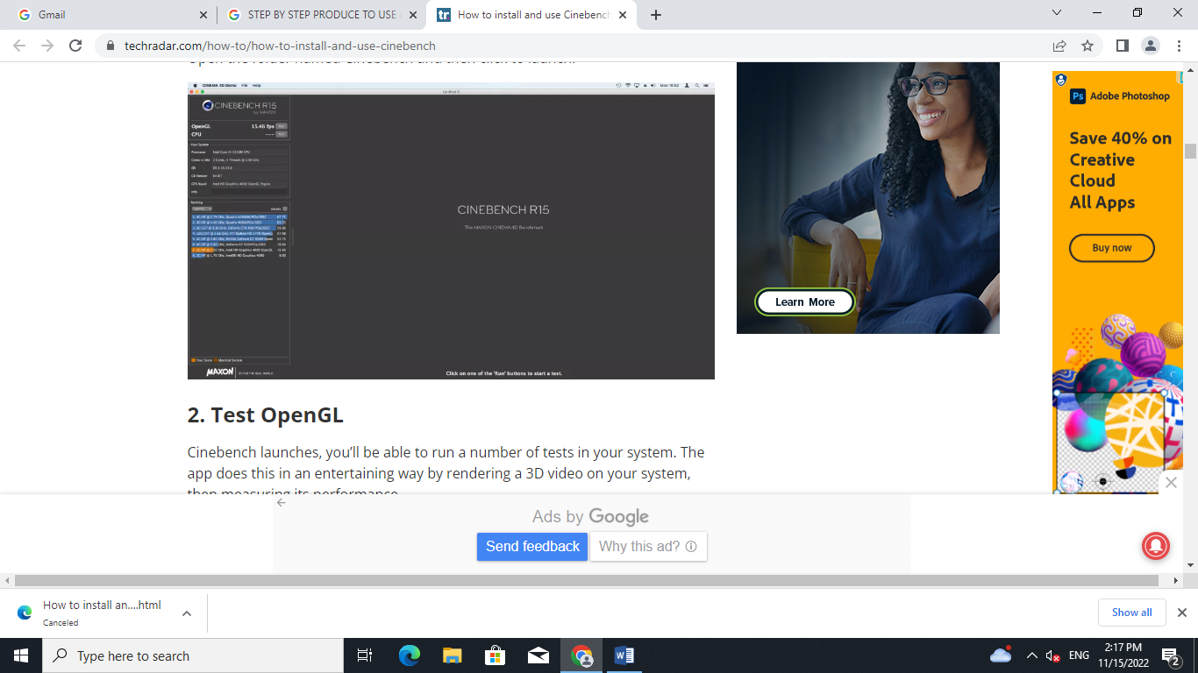

## 2. Test OpenGL

Cinebench launches, you’ll be able to run a number of tests in your system. The app does this in an entertaining way by rendering a 3D video on your system, then measuring its performance.

For instance, to check how nicely OpenGL works in your system, click the ‘Run’ button at the very top-left. Cinebench will display an epic video of a car race and then evaluate your performance in fps. You'll also see how this compares to similar models of computer under ‘Ranking’.

To a more informative view, click ‘Details’ in the left-hand pane. From here you can have Cinebench display further useful titbits such as ‘OpenGL version’ and specs for your current CPU.

To run more comprehensive tests on your processor, click ‘Run’ next to the CPU option. Cinebench will benchmark your processor by rendering a high-quality 3D image. Your CPU performance will naturally also be affected if you have any other running programs.

For a fair test, make sure you close down any other apps beside Cinebench beforehand. Save and close any open files before you do.

Cinebench uses its own scoring system, measured in units of ‘cb’ to measure CPU performance. After you run each test, the app will also show how your CPU compares to other machines.

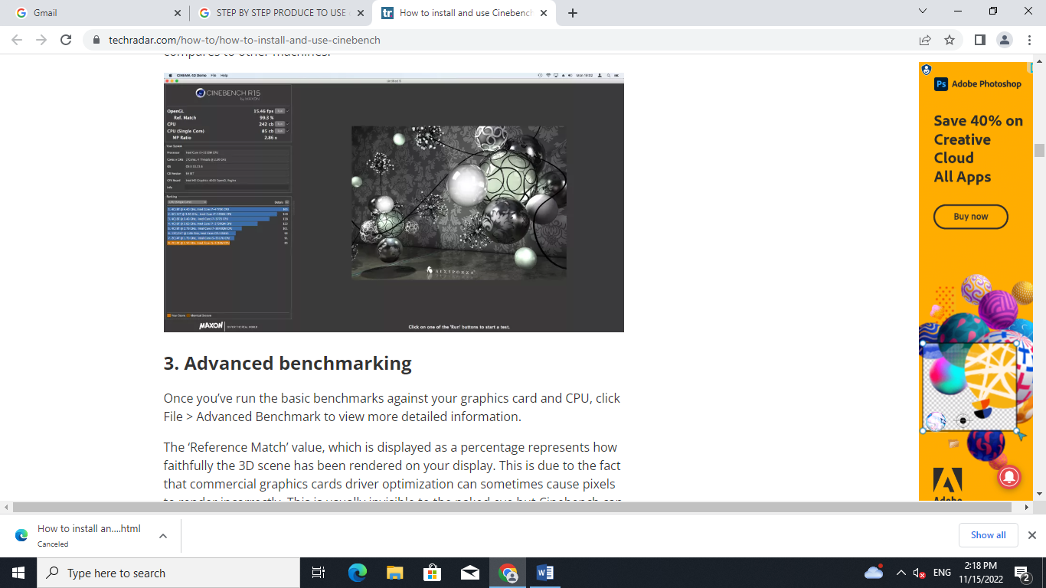

## 3. Advanced benchmarking

Once you’ve run the basic benchmarks against your graphics card and CPU, click File > Advanced Benchmark to view more detailed information.

The ‘Reference Match’ value, which is displayed as a percentage represents how faithfully the 3D scene has been rendered on your display. This is due to the fact that commercial graphics cards driver optimization can sometimes cause pixels to render incorrectly. This is usually invisible to the naked eye but Cinebench can measure the reference match for any completed tests.

Click ‘Run’ beside ‘CPU (Single Core)’ to view a more detailed breakdown of your processor's performance. This will measure the speed measured in ‘cb’ of individual processor cores. Cinebench will also display your MP Ratio - the ratio between single core and multi core.

Cinebench compares your system performance to other identical models where possible. The key for this is displayed at the bottom left of the screen. This shows an orange box which represents your score after rendering and a brown box which represents an identical system in the ranking list. All other systems are highlighted in blue.

## 

## 4.  Submit your benchmark results

Cinebench maintains a huge online database of tests run by users. This is enormously helpful, as it helps you determine where your system should appear in terms of rankings.

To share your benchmark results, go to the [Submit Benchmarks website](https://us.rebusfarm.net/en/lets-go/submit-benchmark)(opens in new tab). From here you can fill in a form with your scores from any rendering tests that you’ve performed via the Cinebench app. You will be asked to enter your CPU and CPU (Single Core) score.

Under the ‘Screenshot’ section click ‘Choose File’ to upload the screenshot of your results. Make sure that the image is to the specifications laid out by the website.

Enter your hardware details in the ‘My Workspace’ section. If your hardware is not listed, choose ‘Other’ from the ‘Model’ menu and enter the name.

## 

## 5. Cinebench CLI

If you are a power user, you may prefer to use Cinebench via the command line. This is generally a better way to benchmark your system as the command line prompt uses very few system resources.

There are various tests you can run, and you can also save the results to a log file.

To get started, open your prompt and launch Cinebench with one of the following parameters:

-cb_gpux

This runs a multi core test.

-cb_cpu1

This runs only the single core test procedure.

-cb_opengl

This tests openGL.

-cb_all

This runs all tests. You can specify a log file to store test results after the command line parameters e.g:

C:\Users\Nate\test1.log

**RESULT:**

Performance Analysis Of Cooling Systems In Pcs (Setup A Benchmark Software -E.G: Cinebench To Perform This), Thereby Write The Need Of Efficient Cooling Systems is executed successfully

**Experiment 9**

setup and configuration of ROM BIOS

**aim**

To setup and configuration of ROM BIOS

**Procedure**

BIOS has a Setup utility stored in the BIOS flash memory. The configured data is provided with context-sensitive Help and is stored in the system's battery-backed CMOS RAM. If the configuration stored in the CMOS RAM is invalid, the BIOS settings default to the original state specified at the factory.

**Working**

**Using BIOS Setup Utility Menu Items**

You can access BIOS Setup utility screens from the following interfaces:

* Use a USB keyboard, mouse, and VGA monitor connected directly to the server.
* Use a terminal (or terminal emulator connected to a computer) through the serial port on the back panel of the server.
* Connect to the server using the Sun ILOM Remote Console.

To access BIOS configuration screens and to change the system’s parameters, complete the following steps:

**1.****Power on or power cycle the server.**

**2. To enter the BIOS Setup utility, press the F2 key while the system is performing the power-on self-test (POST)**

**Press F2 to Run Setup Prompt**

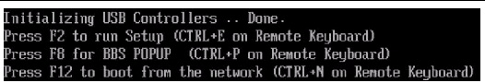

**BIOS Setup Utility - Main Screen**

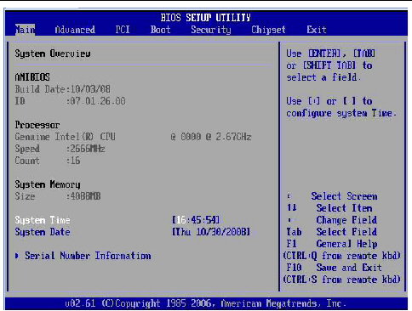

**3.****Use the left and right arrow keys to select the different menu options.**

As you select each menu option, the top-level screen for that menu option appears.

**4. To select an option on a top-level screen, use the up and down arrow keys to scroll up and down the options presented.**

Only options that can be modified are highlighted when you press the up and down arrow keys.

* If a field can be modified, as you select the option, user instructions for modifying the option appear in the right column of the screen.
* If a field is a link to a sub-screen, instructions to press the **Enter** key to access the sub screen appear in the right column.

**5.****Modify the setup field and press the Esc key to save the changes and exit the screen.**

Some screens present a confirmation dialog box that enables unwanted changes to be retracted.

**6.****On sub-screens that only provide configuration information and cannot be modified, press the Esc key to exit the screen.**

**7. To continue modifying other setup parameters, repeat**[**Step 3**](https://docs.oracle.com/cd/E19477-01/820-5830-13/app_bios.html#50634772_30220)**through**[**Step 6**](https://docs.oracle.com/cd/E19477-01/820-5830-13/app_bios.html#50634772_31914)**. Otherwise, go to**[**Step 8**](https://docs.oracle.com/cd/E19477-01/820-5830-13/app_bios.html#50634772_36618)**.**

**8.****Press and release the right arrow key until the Exit menu screen appears.**

**9. Follow the instructions on the Exit menu screen to save or discard your changes and exit the BIOS Setup utility.**

**BIOS Setup Utility Menu Screens**

The following figures show sample Sun Fire X4170, X4270, and X4275 Servers BIOS Setup utility screens.

All settings are set to the optimal defaults at startup.

The following topics are covered:

### BIOS Main Menu Screens

The BIOS Main screens provide general product information, including BIOS, processor, system memory, and system time/date.

The Sun Fire X4170, X4270, and X4275 Servers have the following BIOS Main screens.

**BIOS Setup Utility: Main - System Overview**

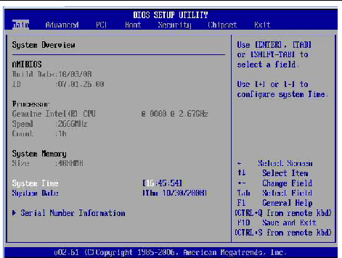

**BIOS Setup Utility: Main - Serial Number Information**

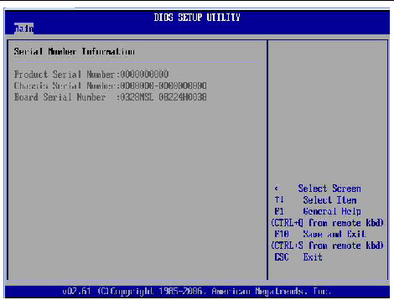

### BIOS Advanced Menu Screens

The BIOS Advanced screens provide detailed configuration information for the CPU, memory, IDE, Super IO, trusted computing, USB, PCI, MPS and other system information.

The Sun Fire X4170, X4270, and X4275 Servers have the following BIOS Advanced screens.

**BIOS Setup Utility: Advanced - Advanced Settings**

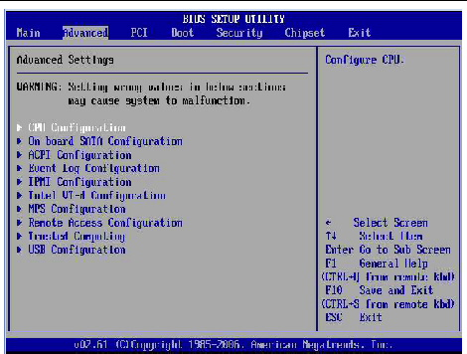

**BIOS Setup Utility: Advanced - Configure Advanced CPU Settings**

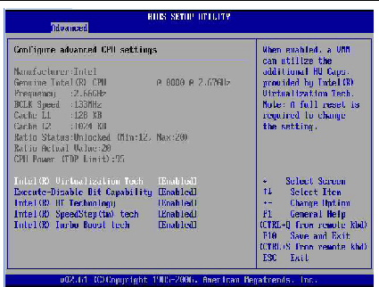

**BIOS Setup Utility: Advanced - On-board SATA Configuration**

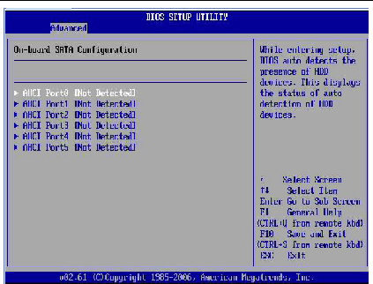

**BIOS Setup Utility: Advanced - AHCI Port 0 Configuration**

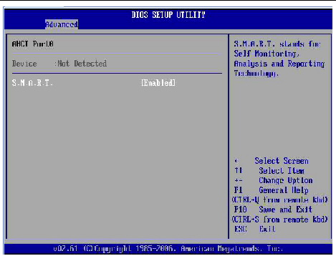

**BIOS Setup Utility: Advance - ACPI Settings**

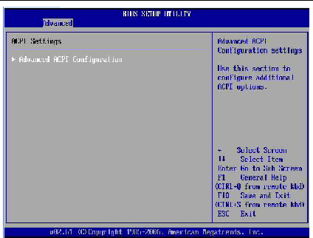

**BIOS Setup Utility: Advanced - Advanced ACPI Configuration**

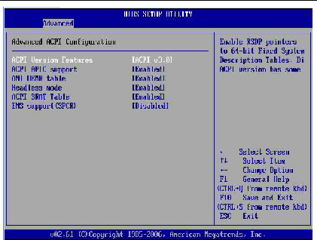

**BIOS Setup Utility: Advanced - Event Logging Details**

**BIOS Setup Utility: Advanced - View Event Log**

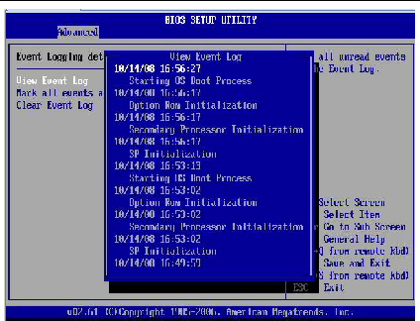

 **BIOS Setup Utility: Advanced - IPMI Configuration**

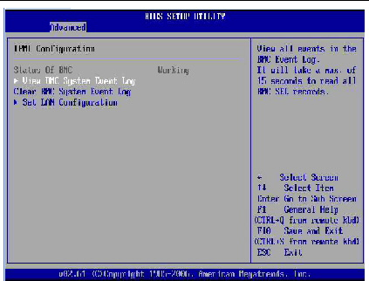

**BIOS Setup Utility: Advanced - LAN Configuration**

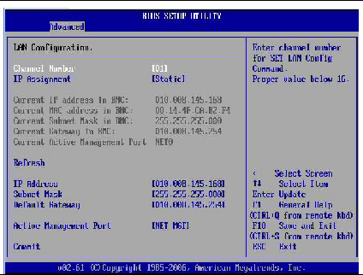

 **BIOS Setup Utility: Advanced - Total Number of Entries**

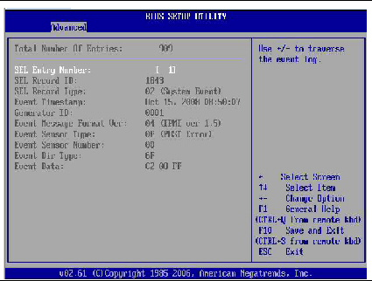

**BIOS Setup Utility: Advanced - Intel VT-d Configuration**

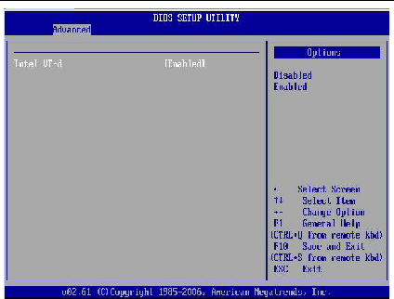

 **BIOS Setup Utility: Advanced - MPS Configuration**

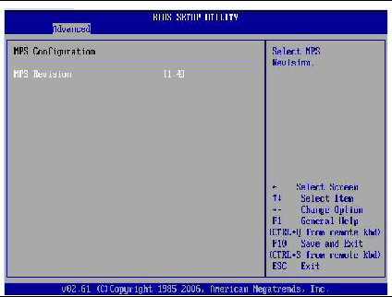

**BIOS Setup Utility: Advanced - Configure Remote Access Type and Parameters**

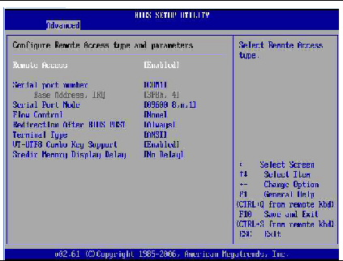

 **BIOS Setup Utility: Advanced - Trusted Computing Configuration**

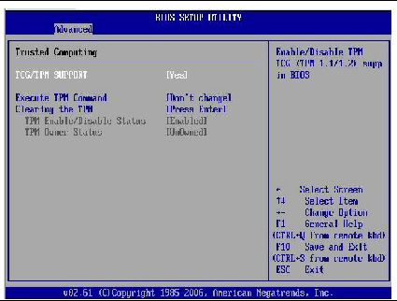

**BIOS Setup Utility: Advanced - USB Configuration**

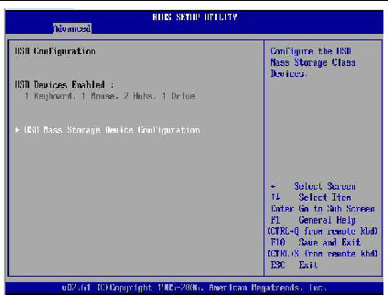

 **BIOS Setup Utility: Advanced - USB Mass Storage Device Configuration**

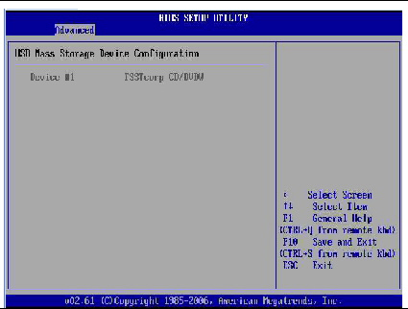

### BIOS PCI Menu Screens

The BIOS PCI screen enables you to configure the server to clear NVRAM during system boot.

The Sun Fire X4170, X4270, and X4275 Servers have the following BIOS PCI screen.

**BIOS Setup Utility: PCI - Advanced PCI Settings**

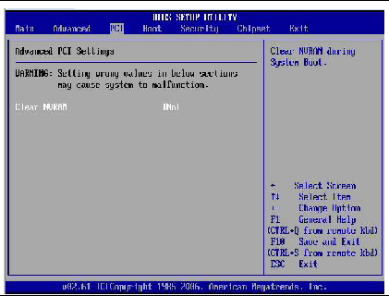

### BIOS Boot Menu Screens

The BIOS Boot screens enable you to configure the boot device priority (storage drives and the DVD-ROM drive).

The Sun Fire X4170, X4270, and X4275 Servers have the following BIOS Boot screens.**BIOS Setup Utility: Boot - Boot Settings**

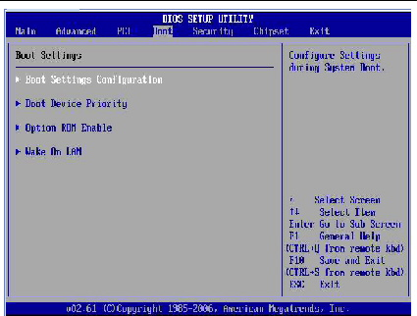

**BIOS Setup Utility: Boot - Boot Settings Configuration**

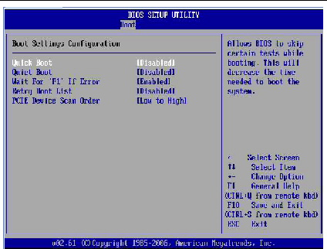

  **BIOS Setup Utility: Boot - Boot Device Priority**

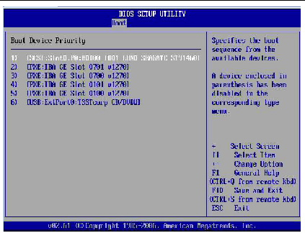

**BIOS Setup Utility: Boot - Option ROM Configuration**

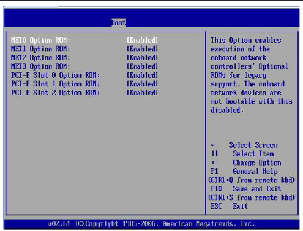

 **BIOS Setup Utility: Boot - Wake On LAN Configuration**

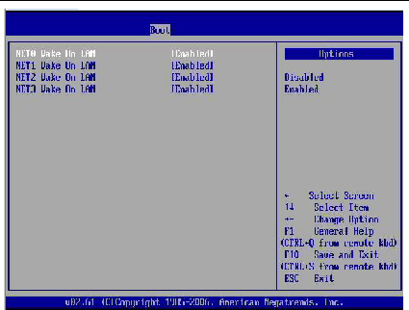

**EX.NO: 10 To capture the image using a mobile phone camera as a web camera.**

**AIM:**

To capture the image using a mobile phone camera as a web camera.

## Working:

## Use Android as an IP Webcam

A typical Android smartphone, old or new, comes with at least one camera. Meanwhile, the Android operating system lets developers create apps that do almost anything. This makes Android an ideal platform for use as an IP webcam.

All you need to do is enable Wi-Fi, find the right app, set it up, then position your Android device as required. The result is a steady IP webcam picture streamed across the web. You can view the footage in any browser.

## Webcam vs. IP Webcam:

webcam is a camera that's connected via USB or built into your computer or other devices. Its purpose is to record video and photos, either for local use or on a video chat program like Skype. On a secure system, the webcam cannot be accessed over the web without your permission. Interestingly, you can also [**use your Android device as a PC webcam**](https://www.makeuseof.com/tag/use-smartphone-webcam-computer/).

An IP camera, meanwhile, is a device intended for streaming video footage across the internet. For example, this might be a traffic cam or another static camera that's publicly accessible. Alternatively, it could be a security camera you can access remotely.

## How to Use Android as an IP Webcam With an App

Several IP camera apps are available for Android. For this project, we've determined that the most useful option is IP Phone Camera by Deskshare. If your phone has an internet connection, this app will turn the device into an IP camera.

The IP Phone Camera app has in-app purchases, but you don't need these for the basic IP camera functionality.

### **IP Phone Camera's Key Features**

* **Wi-Fi:** Directly broadcast to any browser-equipped device on the same network
* **Mobile hotspot:** If your Android phone supports wireless tethering (which it most likely does), broadcast your ad-hoc mobile hotspot.
* **Mobile data:** This paid feature lets you view the webcam from anywhere in the world

The app also offers control options, allowing you to manipulate the camera from the browser. You can:

* Adjust brightness
* Enable flashlight
* Zoom in/out
* Auto-focus
* Rotate
* Switch between front and back cameras

These are all useful remote configuration tools to help you get the best picture possible from your Android IP webcam.



Note some of the other options in the **Settings** screen. Here, you can set the app to automatically **Start broadcasting on app launch**, as well as use the **Video Quality** settings to save bandwidth. There's also a **Require password** option, but that's only available with the Premium subscription for the app.

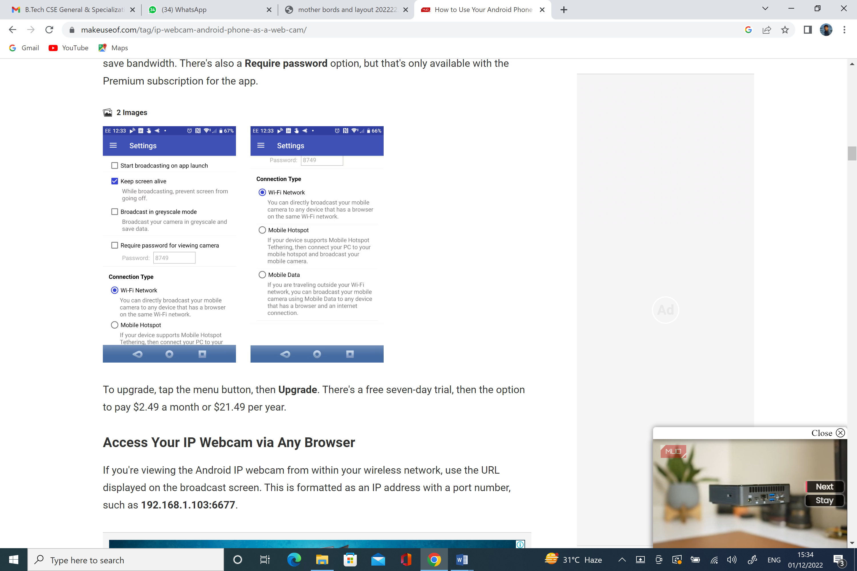

### Access Your IP Webcam via Any Browser

If you're viewing the Android IP webcam from within your wireless network, use the URL displayed on the broadcast screen. This is formatted as an IP address with a port number, such as **192.168.1.103:6677**.

## Controlling the IP Webcam Remotely

The app's browser console includes an easy-to-use touch-friendly panel of controls. Here you can control the zoom and brightness level, rotate the camera, and enable the camera light if necessary.You can also hit **Switch Camera** to flip between front and back cameras on your Android device. You'll spot a **Record Video** feature, too, but this is limited to users of Security Monitor Pro.

**EX.NO:11 Study the operation and maintenance of UPS**

AIM:

To Study the operation and maintenance of UPS .

Principles:

1. **Put safety first.** Life and limb should trump dollars every time. When you’re dealing with electrical power, you’re always one small blunder away from serious injury or death. So when dealing with UPS (or any electrical system in the data center), make sure that safety is a top priority: that includes observing manufacturer recommendations, paying attention to the peculiar implementation details in the facility and following standard safety guidelines. If you’re not sure about some aspect of your UPS system or how to maintain or service it, call a professional. And even if you do know your UPS system inside and out, getting outside assistance can still be warranted—if for no other reason than it involves potentially cooler heads that aren’t dogged by the same pressures.
2. **Schedule maintenance—and stick with it.** Preventive maintenance shouldn’t be something that you’ll just “get around to,” particularly given the potential costs of downtime. For your UPS—as with other data center systems—you should schedule regular maintenance activities (annual, semiannual or whatever the time frame) and stick with that schedule. That includes keeping a written (on paper or electronic) record listing upcoming maintenance activities and whether/when past maintenance was performed.
3. **Keep detailed records.** In addition to scheduling maintenance, you should also keep records of the kinds of maintenance performed (for instance, cleaning, repair or replacement of certain components) and the condition of the equipment during inspection. Keeping track of costs can also be beneficial when you need to show the C-suite that a few dollars in maintenance costs beats thousands or millions in downtime costs every time. A checklist of tasks, such as inspecting batteries for corrosion, looking for excessive torque on connecting leads and so on, helps maintain an orderly approach. All of this documentation can help when planning for equipment replacement or unscheduled repair and when troubleshooting the UPS. In addition to keeping records, be sure to keep them consistently in an accessible and well-known location.
4. **Perform regular inspections.** Much of the above can apply to almost any part of the data center: enforcing safety, scheduling maintenance and keeping good records are all excellent practices regardless of the data center context. For UPSs in particular, however, some tasks can and should be performed regularly by staff (who should become familiar with at least the basics of UPS operation). A few important UPS maintenance tasks include the following:
   * *Visually inspect of the area around UPS and battery (or other energy-storage) equipment for obstructions and proper cooling.*
   * *Ensure no operating abnormalities or warnings have registered on the UPS panel, such as an overload or a battery near discharge.*
   * *Look over batteries for signs of corrosion or other defects.*

Consult manufacturer documentation for guidelines and recommendations for your specific equipment. You should perform maintenance (or hire professionals to do so) as often as the manufacturer recommends at a minimum—in some cases, though, more often may be better.

1. **Recognize that UPS components will fail.**This may seem obvious: anything with a finite probability of failure will fail eventually. Eaton notes that “critical [UPS] components such as batteries and capacitors wear out from normal use,” so even if your utility provides perfect power, your UPS room is perfectly clean and consistently at the proper temperature, and everything is running ideally, components will still fail. Your (yes, *your*) UPS system requires maintenance.
2. **Know whom to call when you need service or unscheduled maintenance.** During daily or weekly inspections, problems can arise that may not be able to wait until the next scheduled maintenance. In these cases, knowing whom to call can save a lot of stress. That means you must identify solid service providers that will be available when you need them (i.e., at odd hours). The provider may be the same as your regular provider or not—but keep all the numbers for maintenance and repair in a readily accessible location. (And if you have your well-kept maintenance records in the same place, you will be able to supply helpful information when the provider arrives, potentially saving lots of time and money in service fees.)
3. **Assign tasks.** “Weren’t you supposed to check that last week?” “No, I thought you were.” Avoid this mess: ensure that the appropriate personnel know their responsibilities when it comes to UPS maintenance. Who checks the equipment weekly? Who calls to schedule (or perhaps adjust the schedule for) annual maintenance with the service provider? The particular tasks may vary, but make sure you know who is responsible for what when it comes to your UPS system.